Part 1

[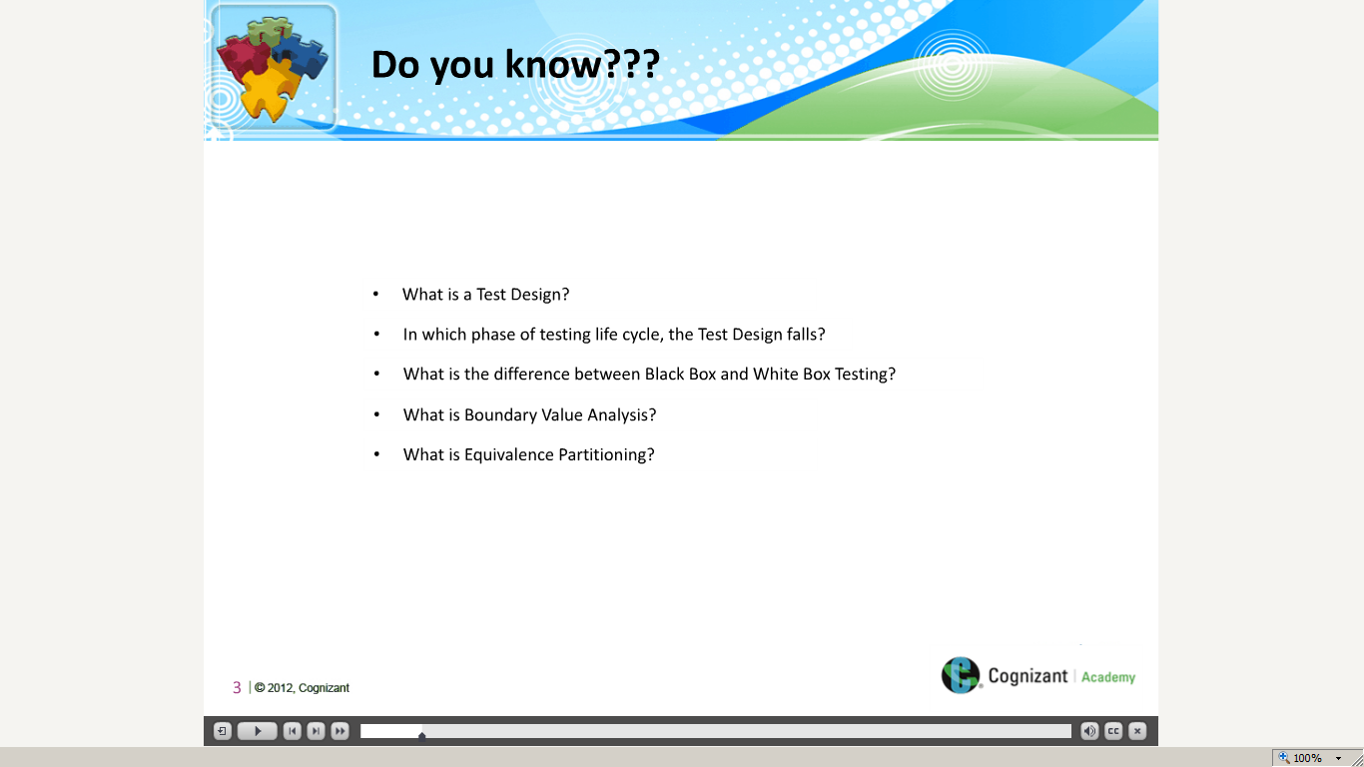](https://compass.learning.cognizant.com/elmprd/elearning/test_design_techniques_overview1/multiscreen.html)

[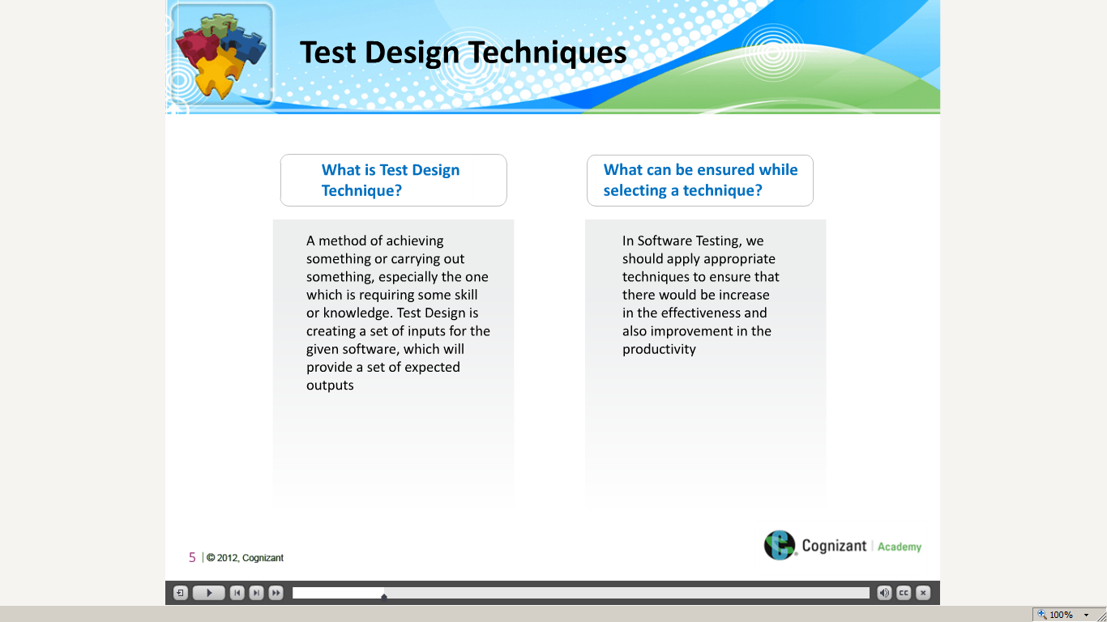](https://compass.learning.cognizant.com/elmprd/elearning/test_design_techniques_overview1/multiscreen.html)

[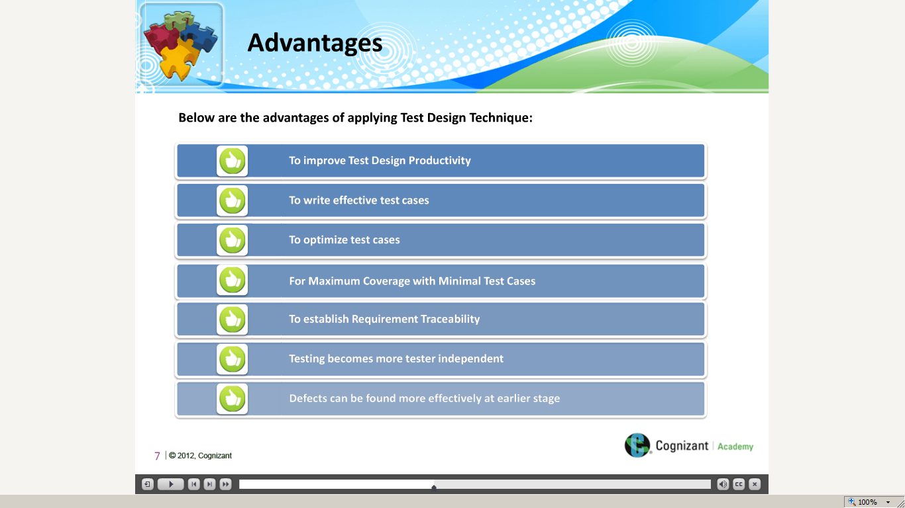](https://compass.learning.cognizant.com/elmprd/elearning/test_design_techniques_overview1/multiscreen.html)

[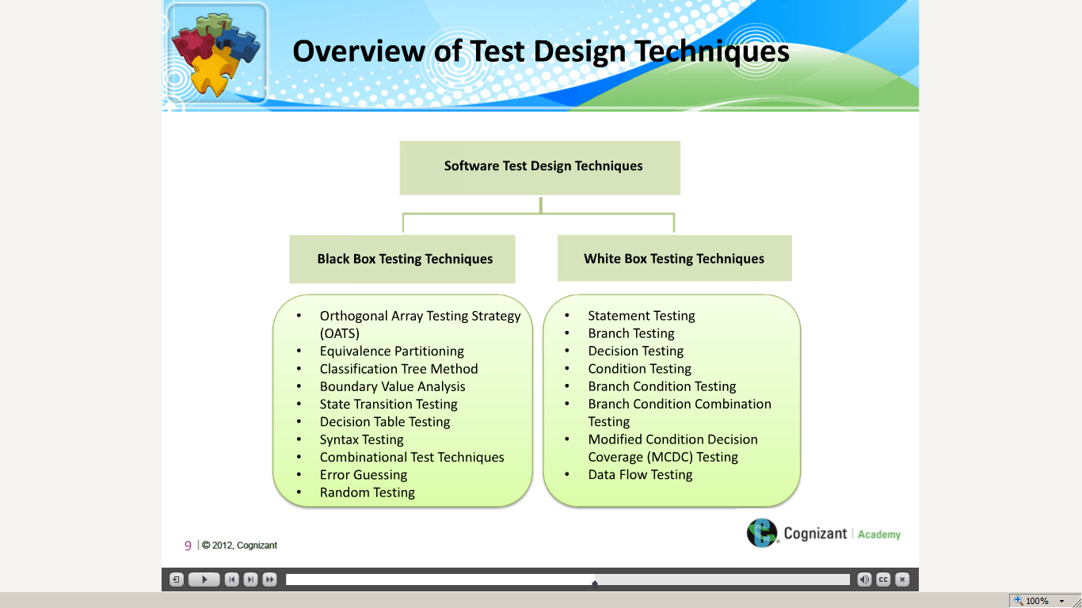](https://compass.learning.cognizant.com/elmprd/elearning/test_design_techniques_overview1/multiscreen.html)

[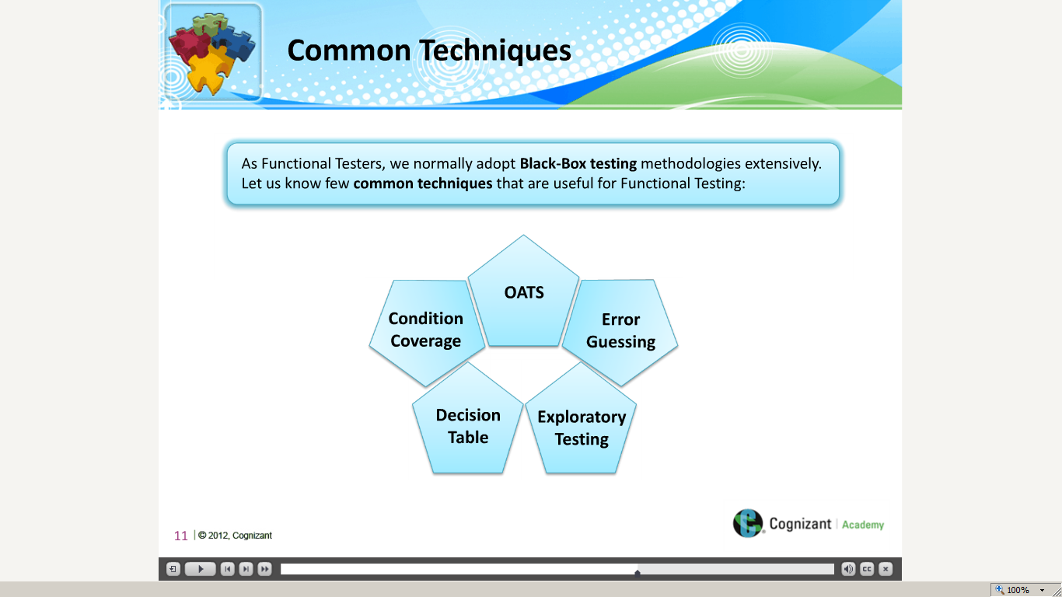](https://compass.learning.cognizant.com/elmprd/elearning/test_design_techniques_overview1/multiscreen.html)

[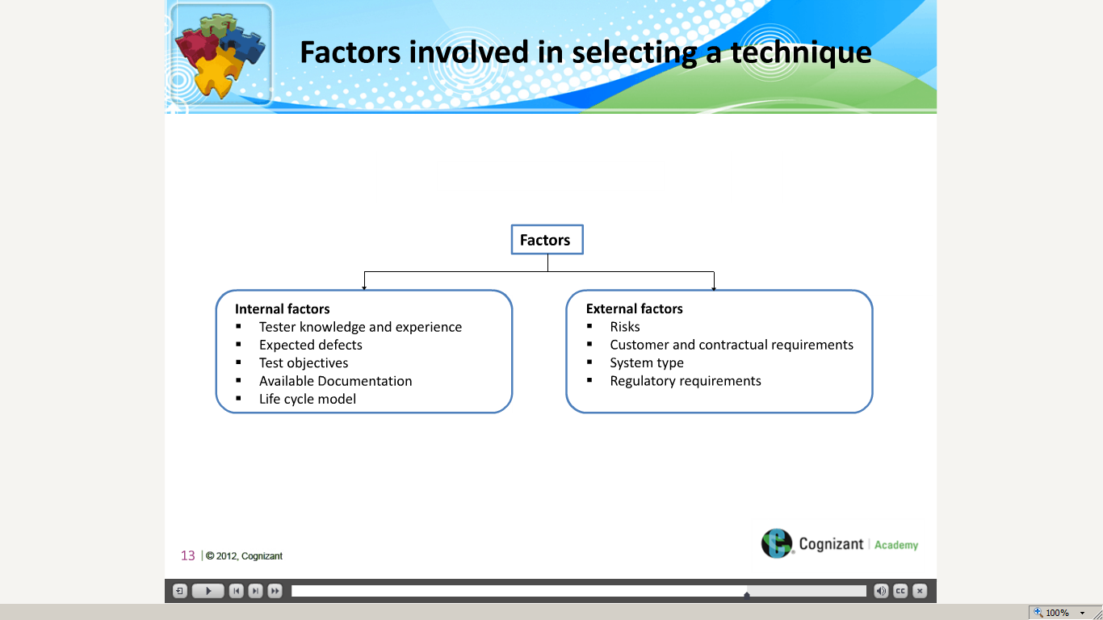](https://compass.learning.cognizant.com/elmprd/elearning/test_design_techniques_overview1/multiscreen.html)

[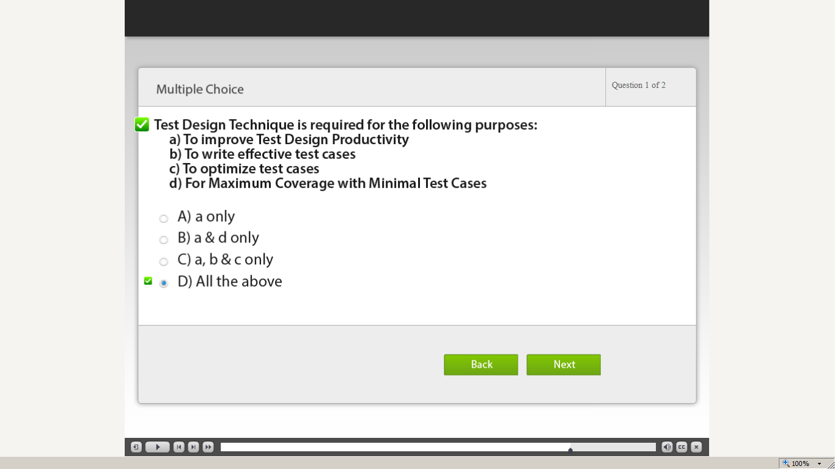](https://compass.learning.cognizant.com/elmprd/elearning/test_design_techniques_overview1/multiscreen.html)

[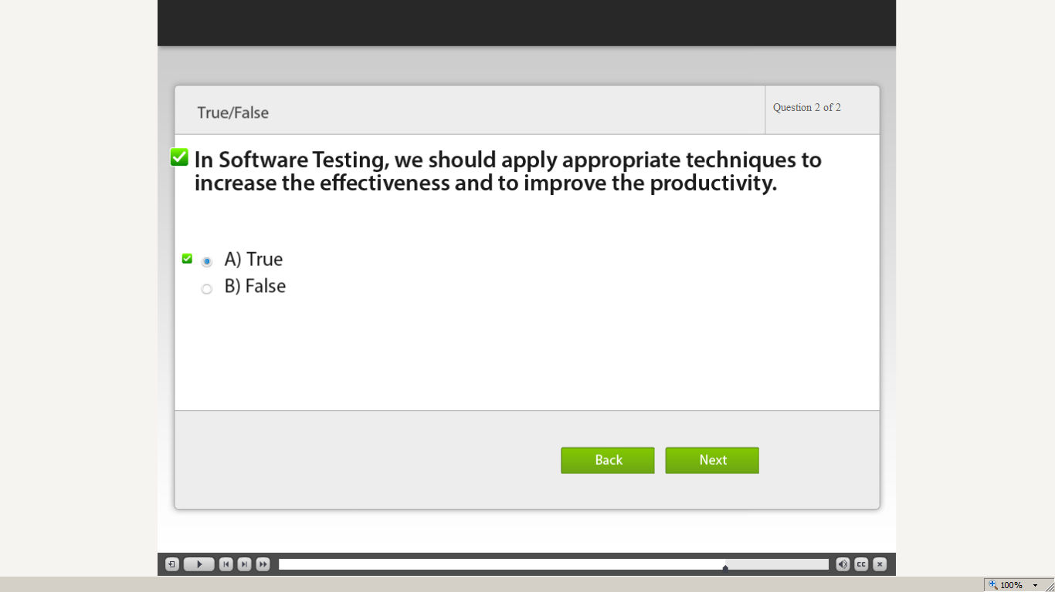](https://compass.learning.cognizant.com/elmprd/elearning/test_design_techniques_overview1/multiscreen.html)

[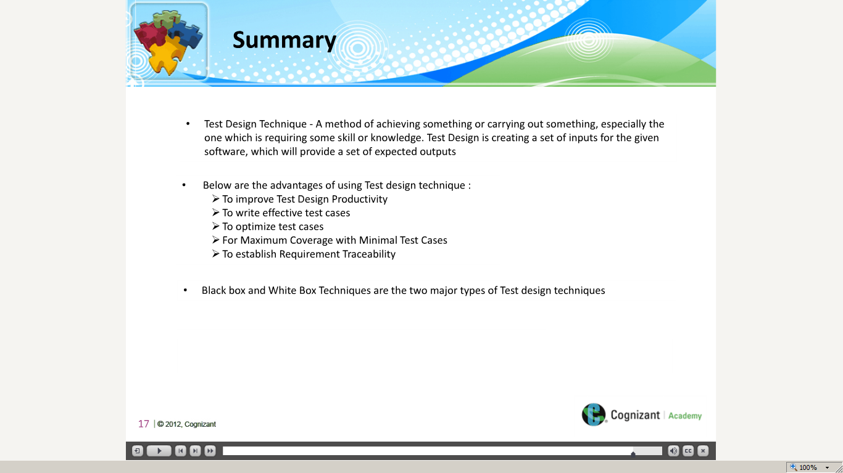](https://compass.learning.cognizant.com/elmprd/elearning/test_design_techniques_overview1/multiscreen.html)

Part 2

[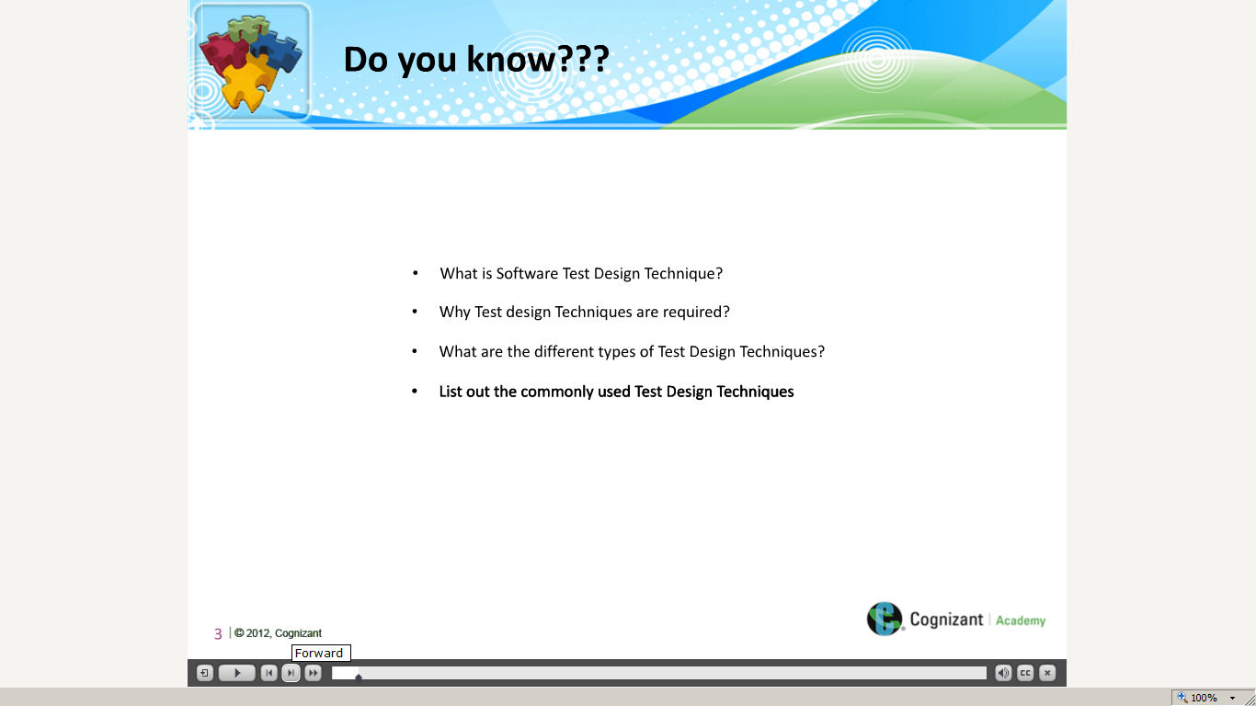](https://compass.learning.cognizant.com/elmprd/elearning/test_design_techniques_decision_table/multiscreen.html)

[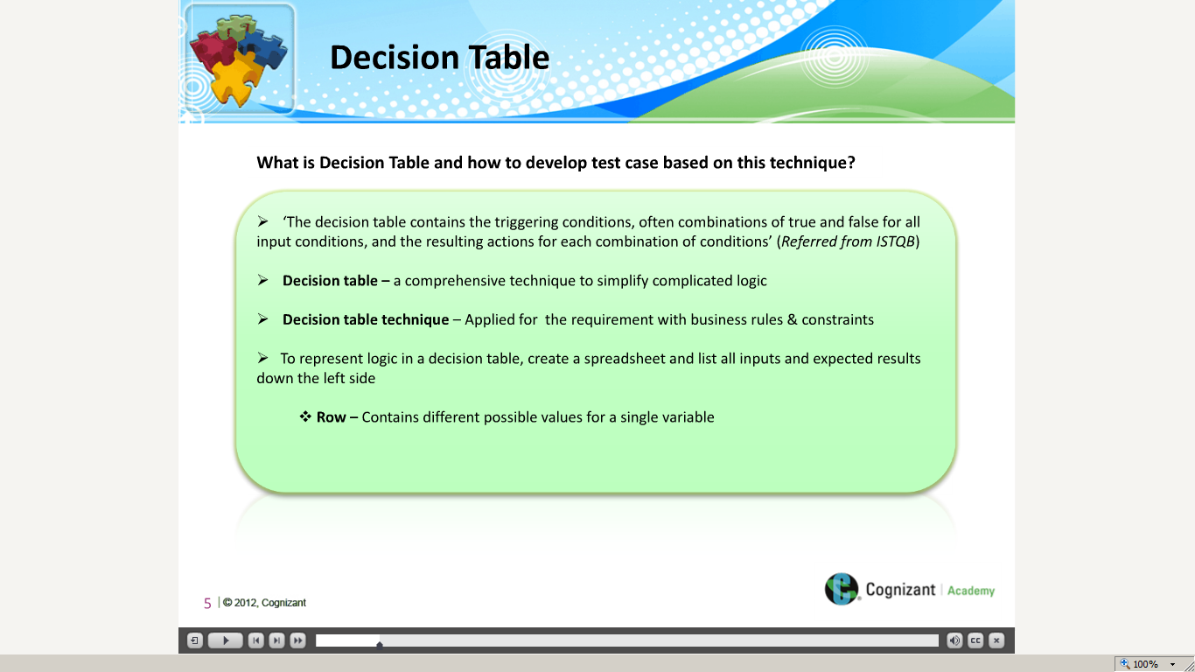](https://compass.learning.cognizant.com/elmprd/elearning/test_design_techniques_decision_table/multiscreen.html)

[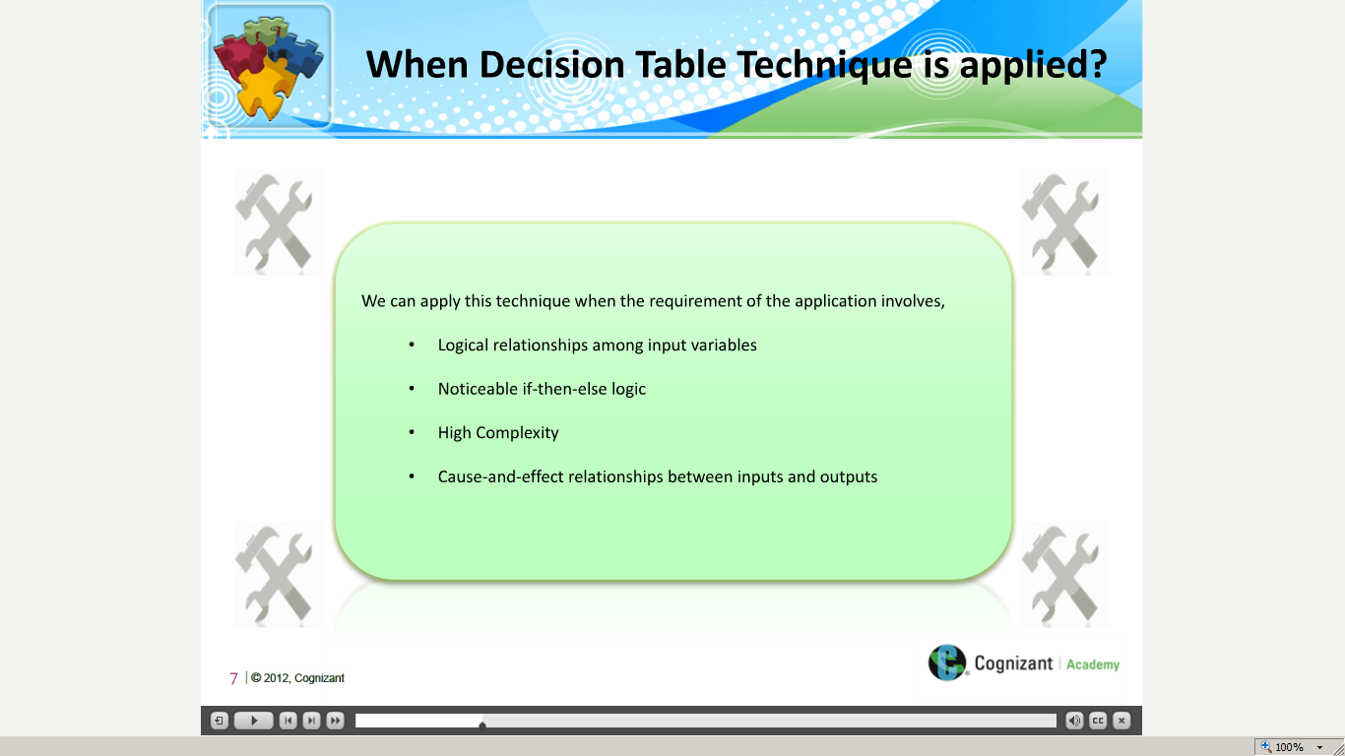](https://compass.learning.cognizant.com/elmprd/elearning/test_design_techniques_decision_table/multiscreen.html)

[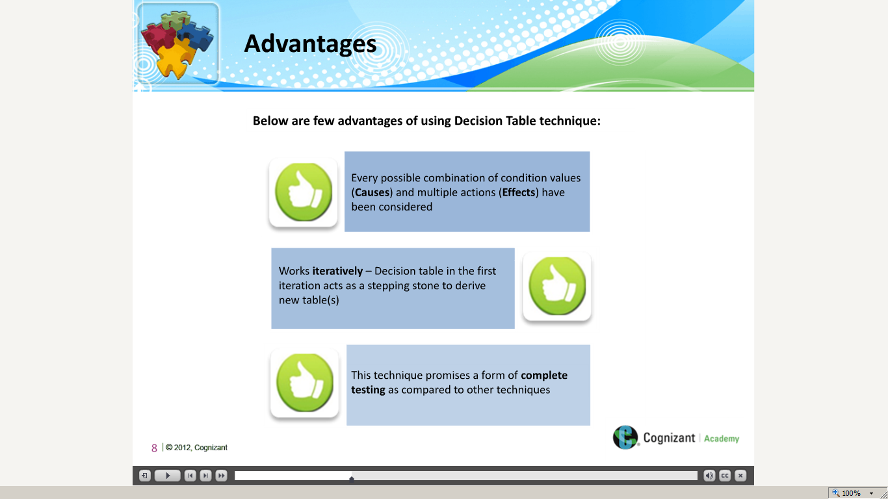](https://compass.learning.cognizant.com/elmprd/elearning/test_design_techniques_decision_table/multiscreen.html)

[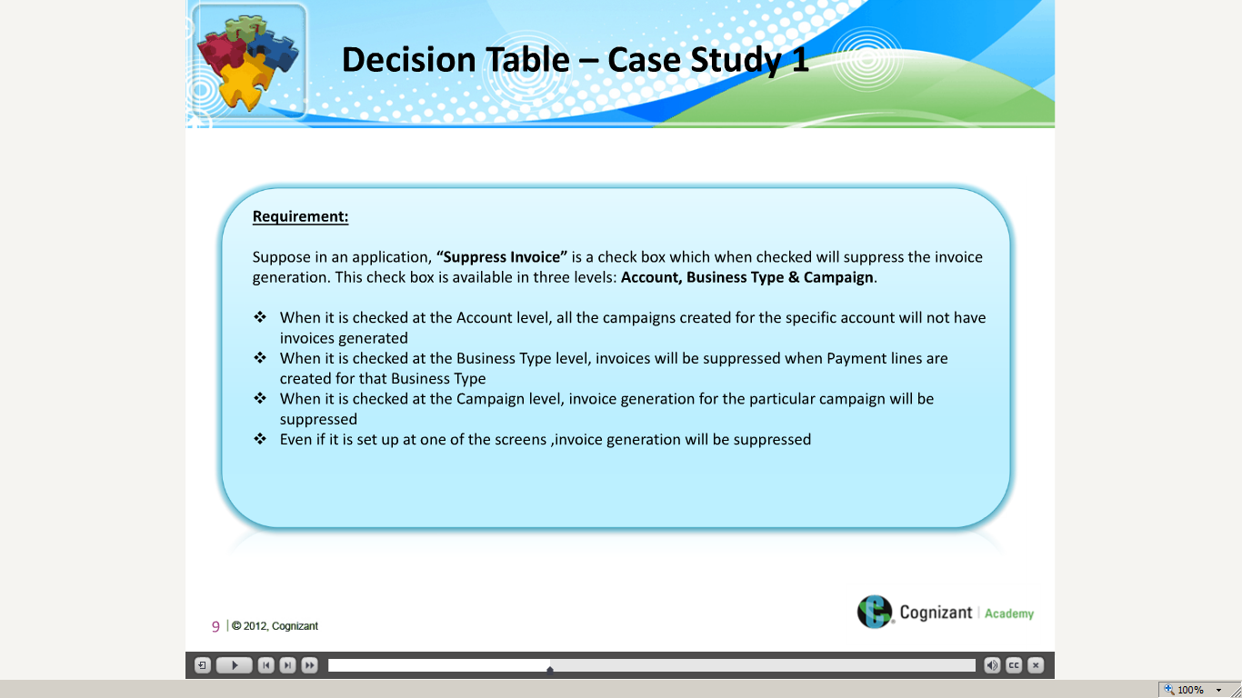](https://compass.learning.cognizant.com/elmprd/elearning/test_design_techniques_decision_table/multiscreen.html)

[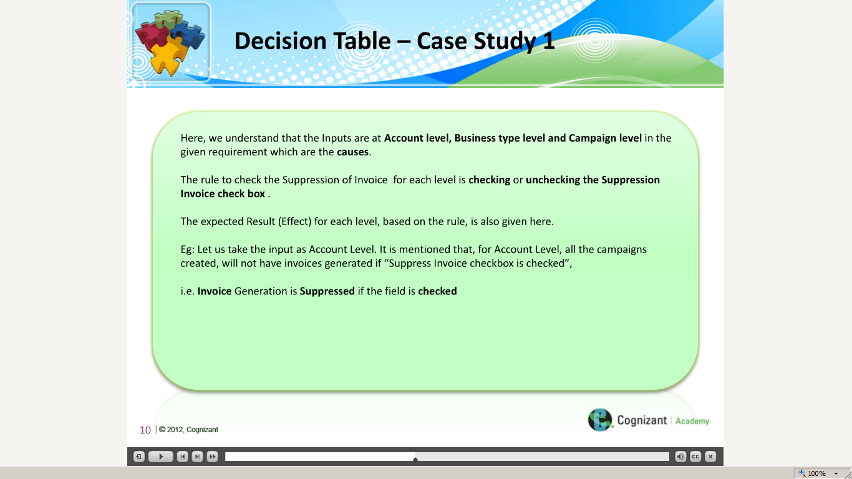](https://compass.learning.cognizant.com/elmprd/elearning/test_design_techniques_decision_table/multiscreen.html)

[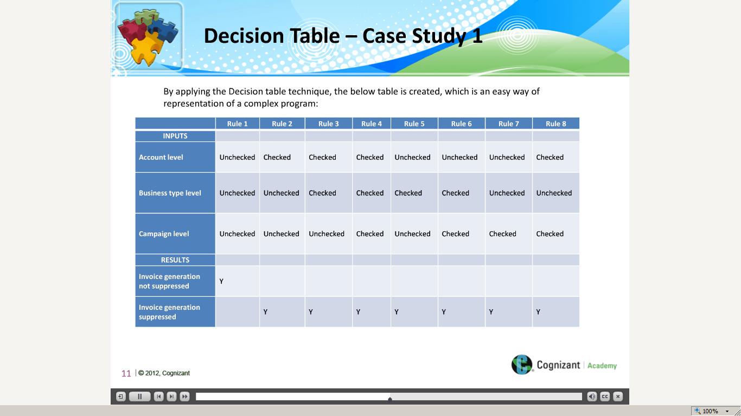](https://compass.learning.cognizant.com/elmprd/elearning/test_design_techniques_decision_table/multiscreen.html)

[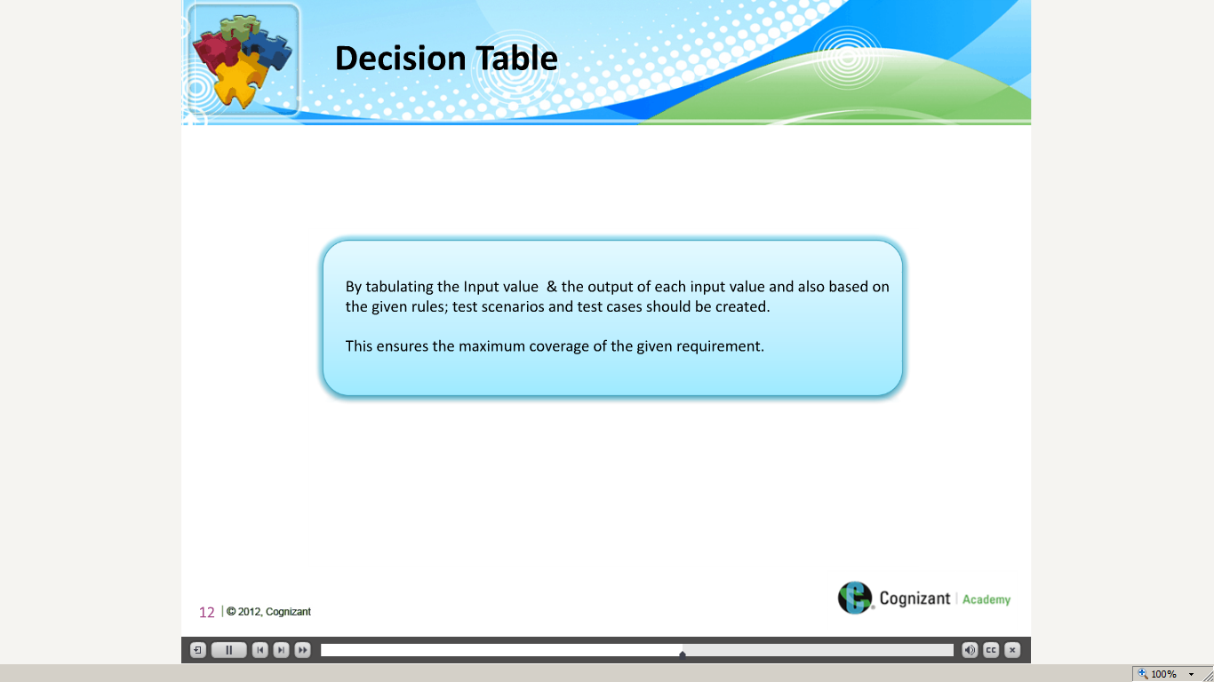](https://compass.learning.cognizant.com/elmprd/elearning/test_design_techniques_decision_table/multiscreen.html)

[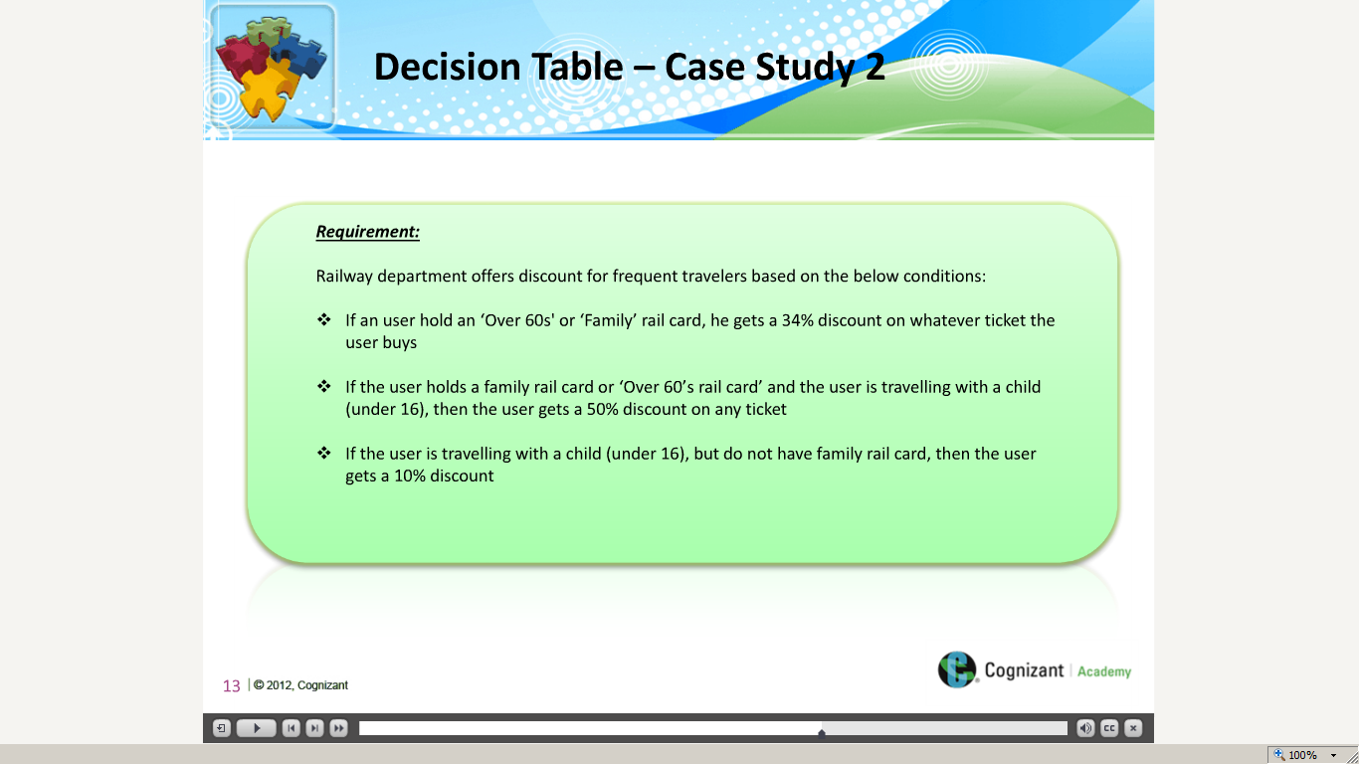](https://compass.learning.cognizant.com/elmprd/elearning/test_design_techniques_decision_table/multiscreen.html)

[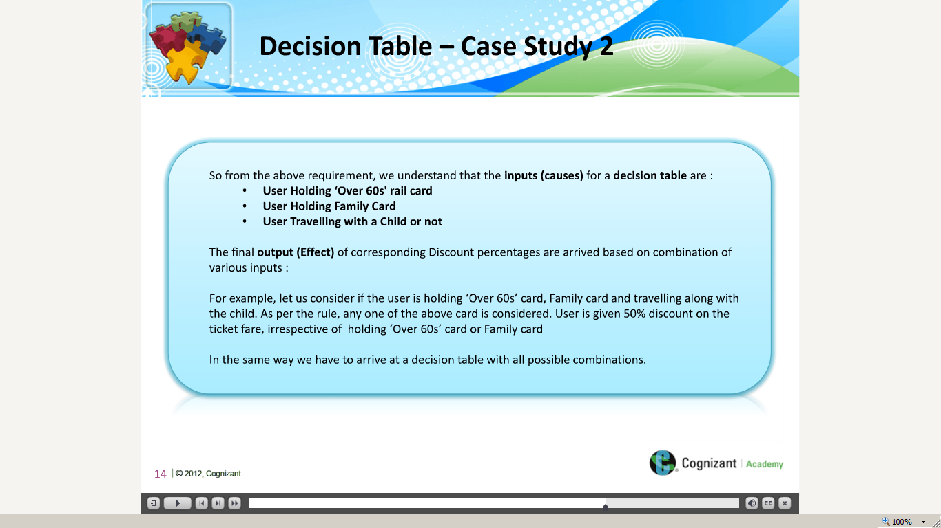](https://compass.learning.cognizant.com/elmprd/elearning/test_design_techniques_decision_table/multiscreen.html)

[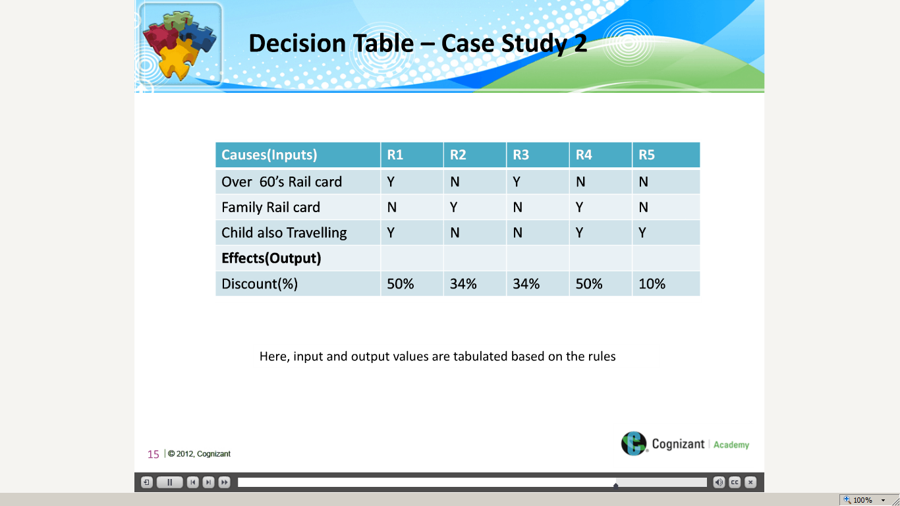](https://compass.learning.cognizant.com/elmprd/elearning/test_design_techniques_decision_table/multiscreen.html)

[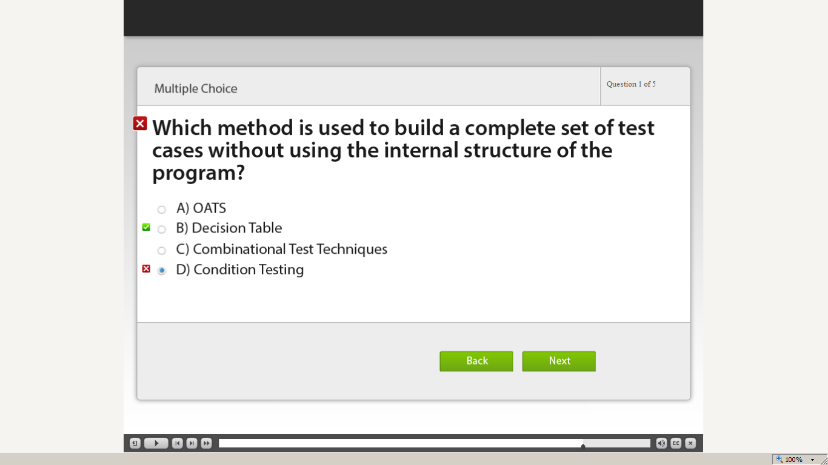](https://compass.learning.cognizant.com/elmprd/elearning/test_design_techniques_decision_table/multiscreen.html)

[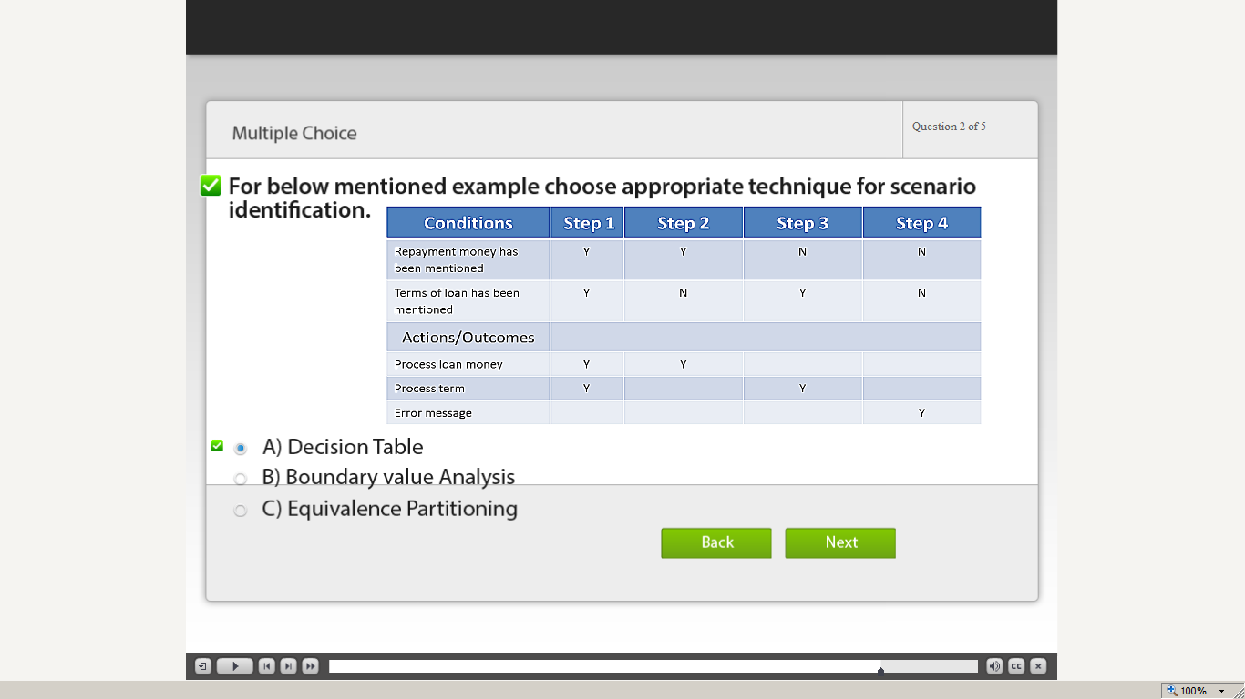](https://compass.learning.cognizant.com/elmprd/elearning/test_design_techniques_decision_table/multiscreen.html)

[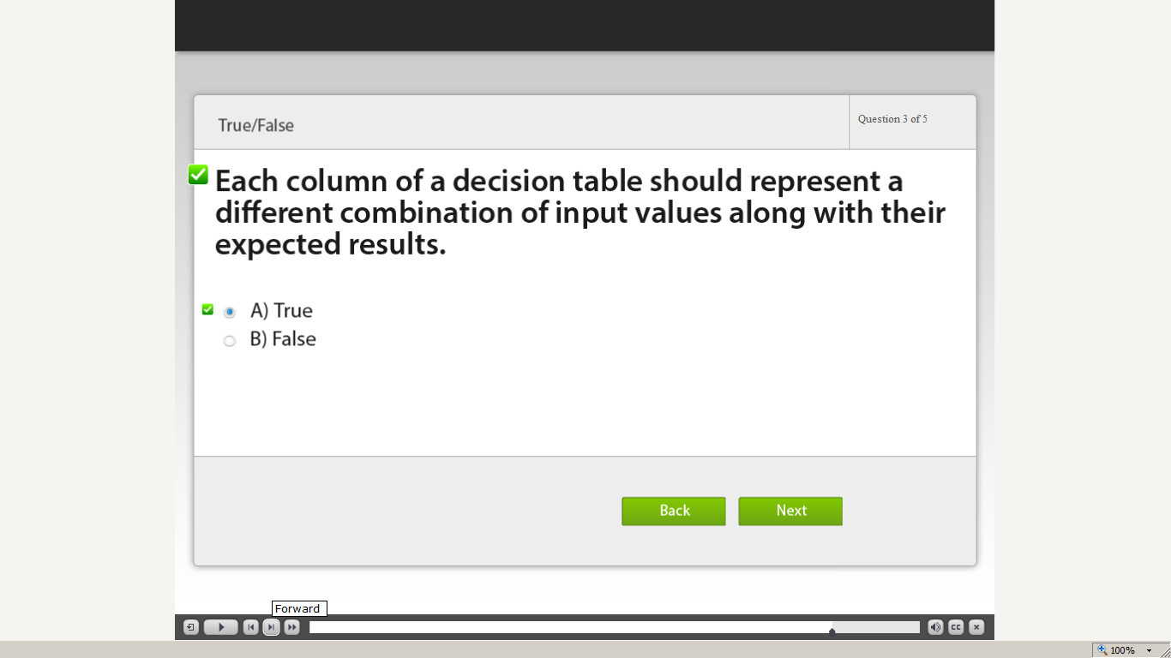](https://compass.learning.cognizant.com/elmprd/elearning/test_design_techniques_decision_table/multiscreen.html)

[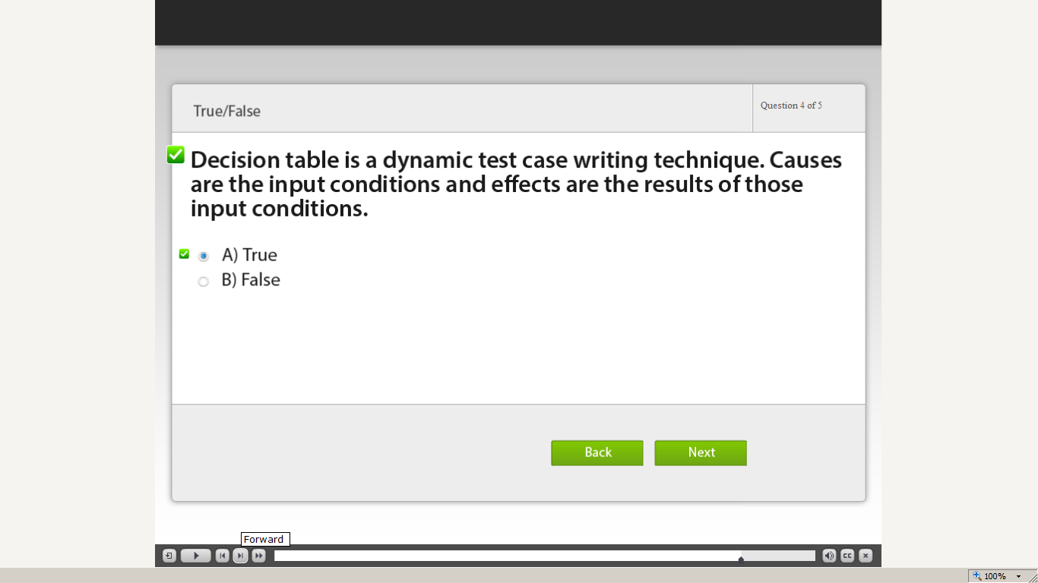](https://compass.learning.cognizant.com/elmprd/elearning/test_design_techniques_decision_table/multiscreen.html)

[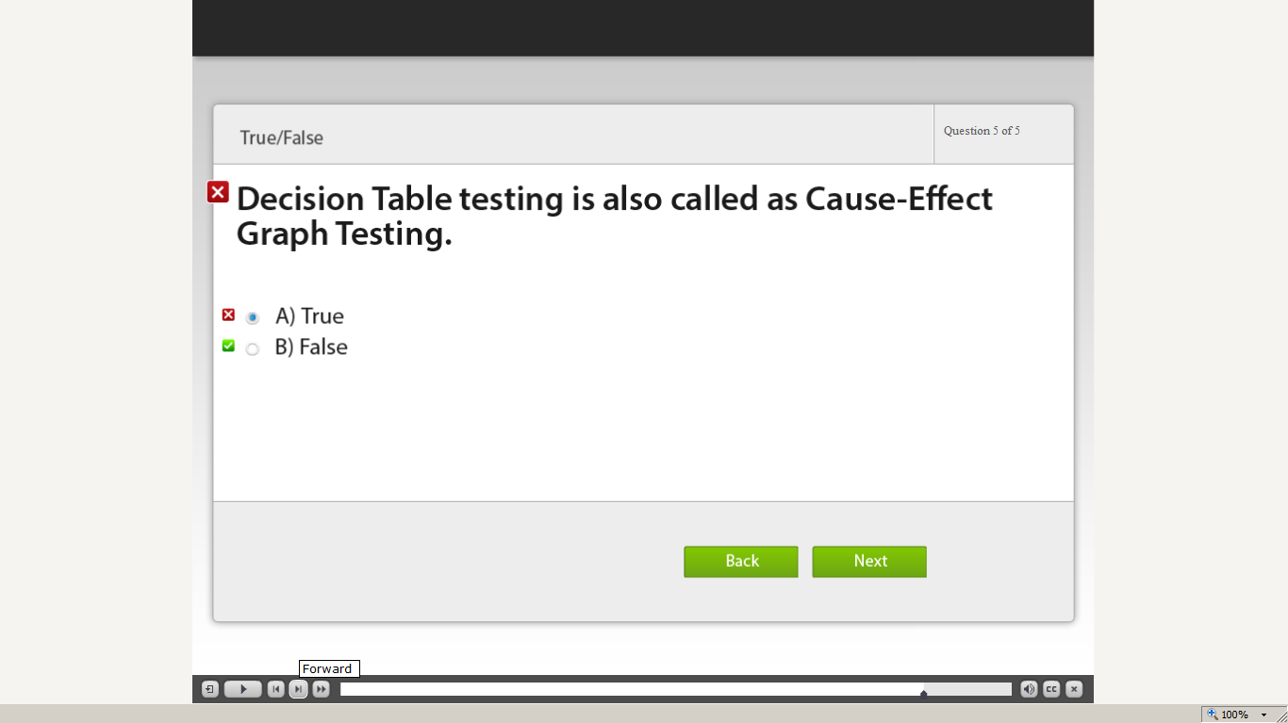](https://compass.learning.cognizant.com/elmprd/elearning/test_design_techniques_decision_table/multiscreen.html)

[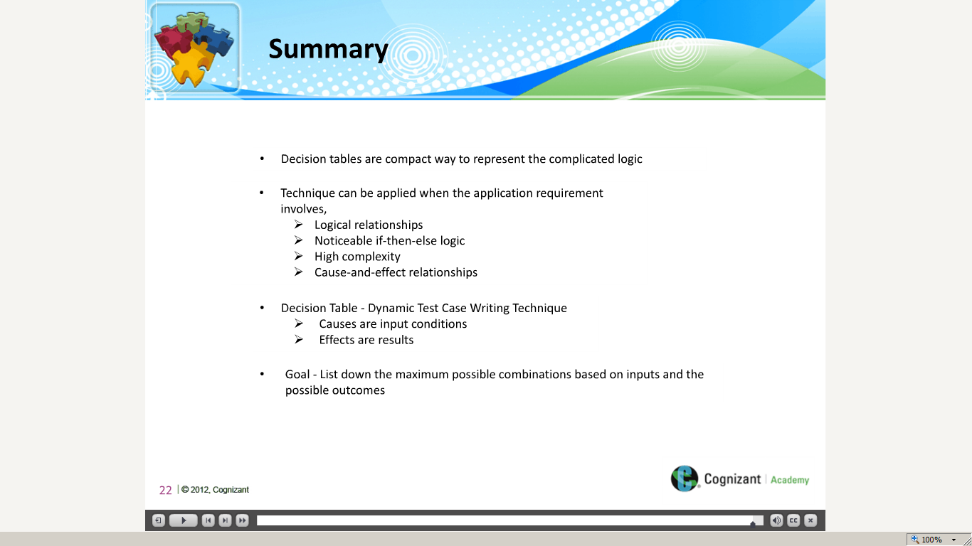](https://compass.learning.cognizant.com/elmprd/elearning/test_design_techniques_decision_table/multiscreen.html)

[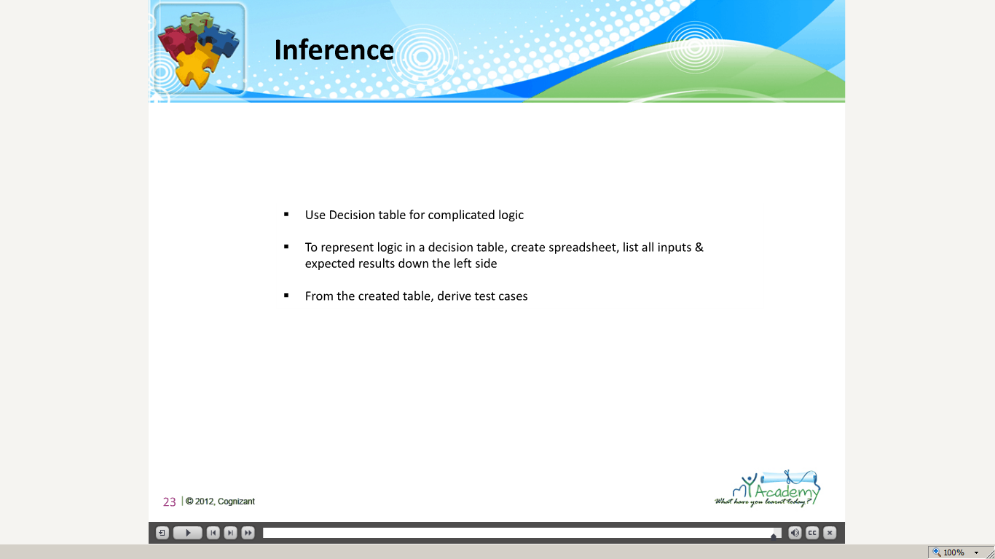](https://compass.learning.cognizant.com/elmprd/elearning/test_design_techniques_decision_table/multiscreen.html)

Part 3

[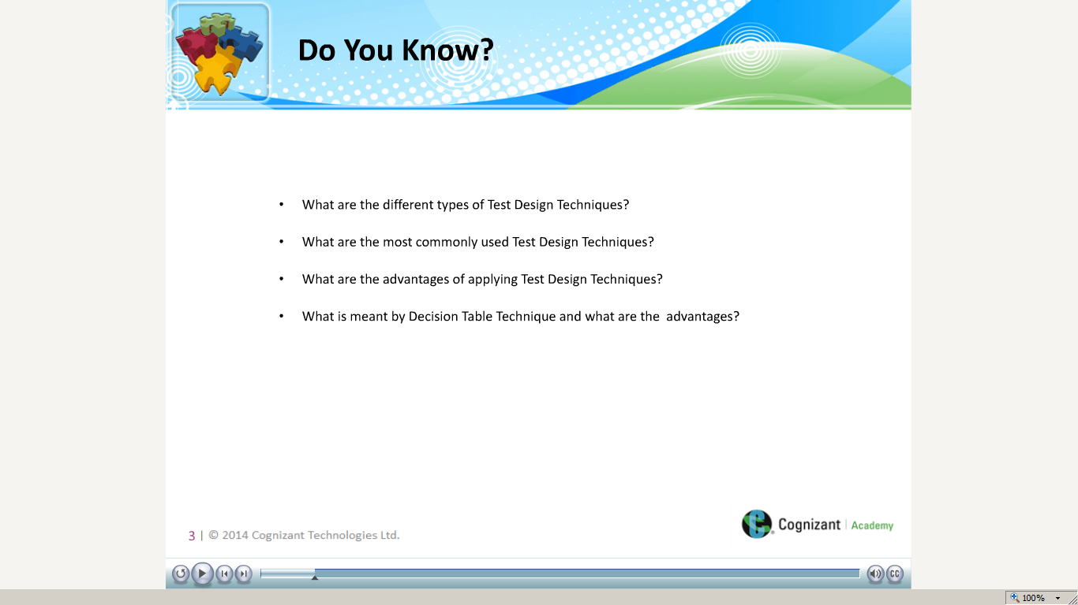](https://compass.learning.cognizant.com/elmprd/elearning/test_design_technique_condition_coverage/multiscreen.html)

[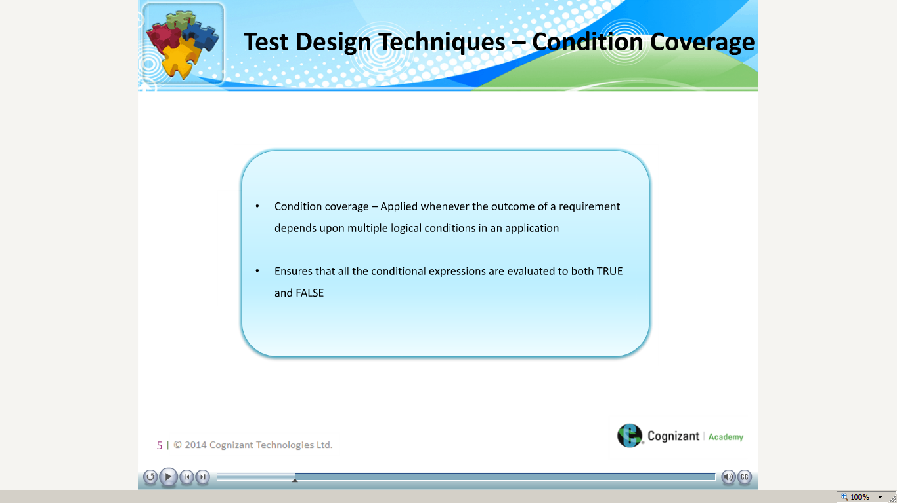](https://compass.learning.cognizant.com/elmprd/elearning/test_design_technique_condition_coverage/multiscreen.html)

[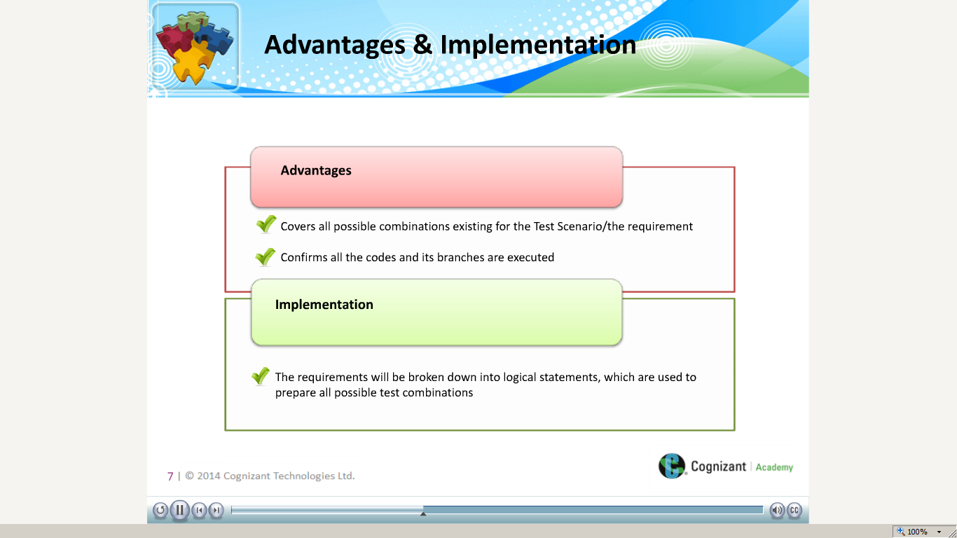](https://compass.learning.cognizant.com/elmprd/elearning/test_design_technique_condition_coverage/multiscreen.html)

[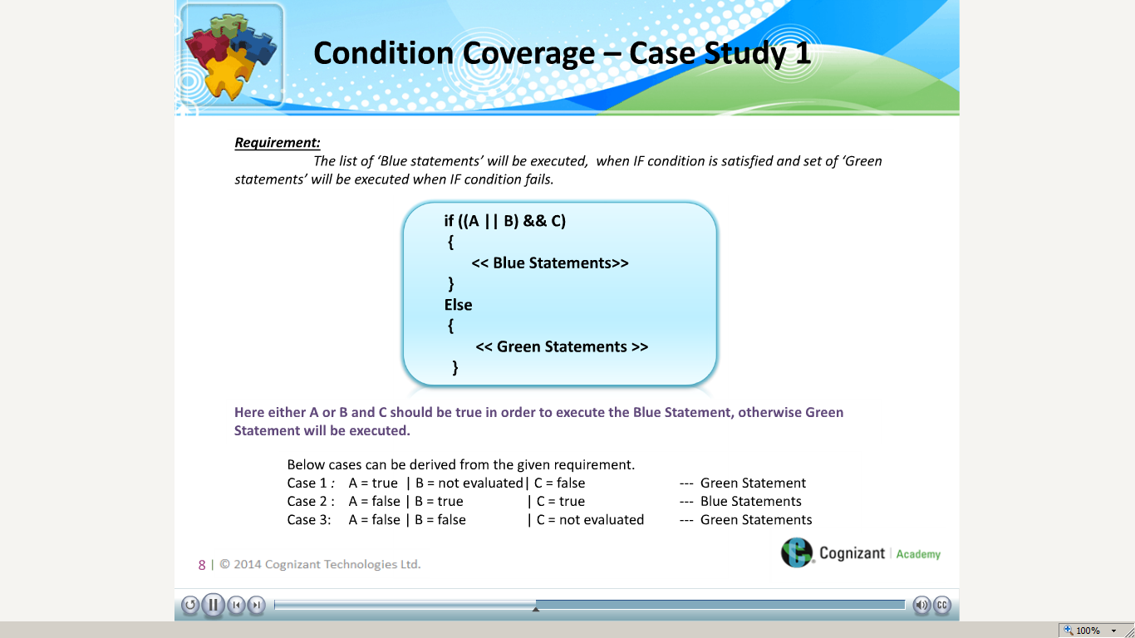](https://compass.learning.cognizant.com/elmprd/elearning/test_design_technique_condition_coverage/multiscreen.html)

[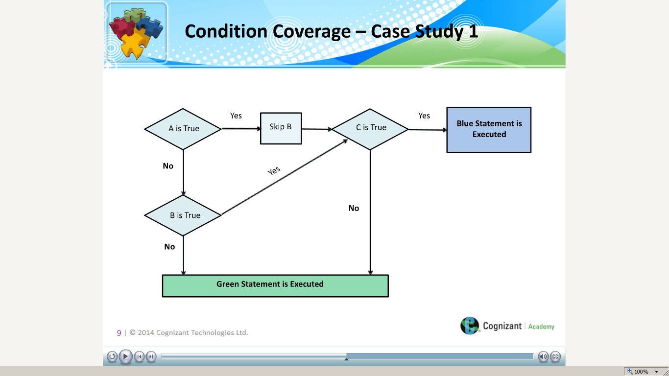](https://compass.learning.cognizant.com/elmprd/elearning/test_design_technique_condition_coverage/multiscreen.html)

[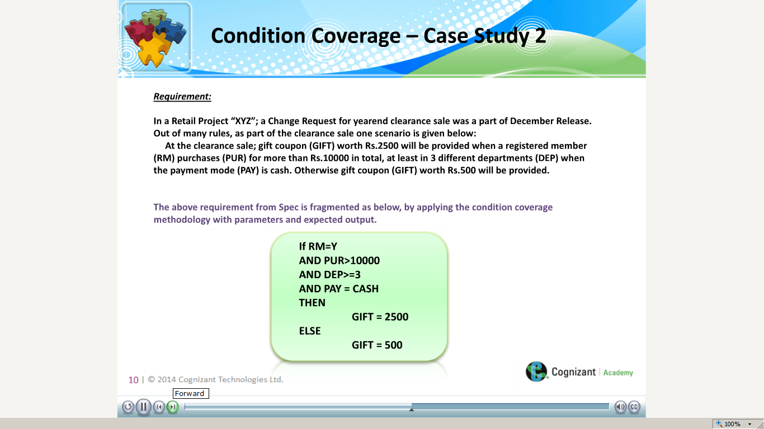](https://compass.learning.cognizant.com/elmprd/elearning/test_design_technique_condition_coverage/multiscreen.html)

[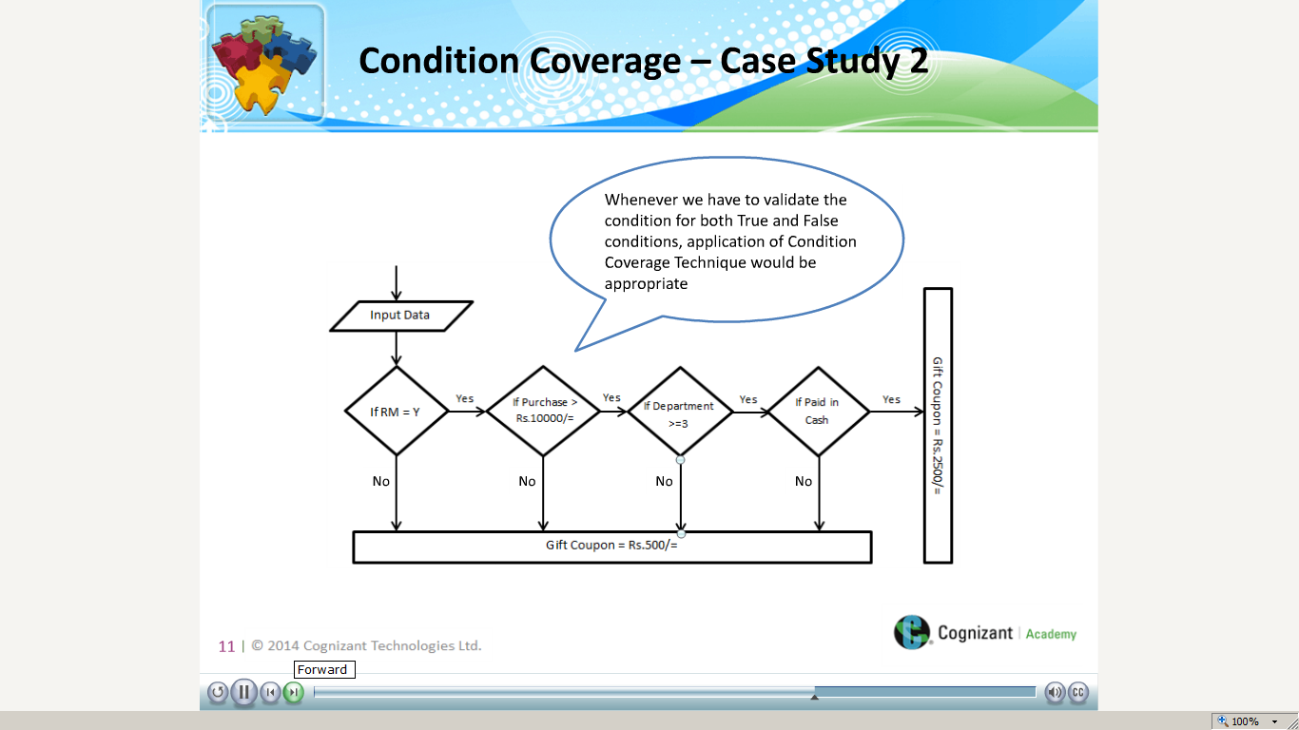](https://compass.learning.cognizant.com/elmprd/elearning/test_design_technique_condition_coverage/multiscreen.html)

[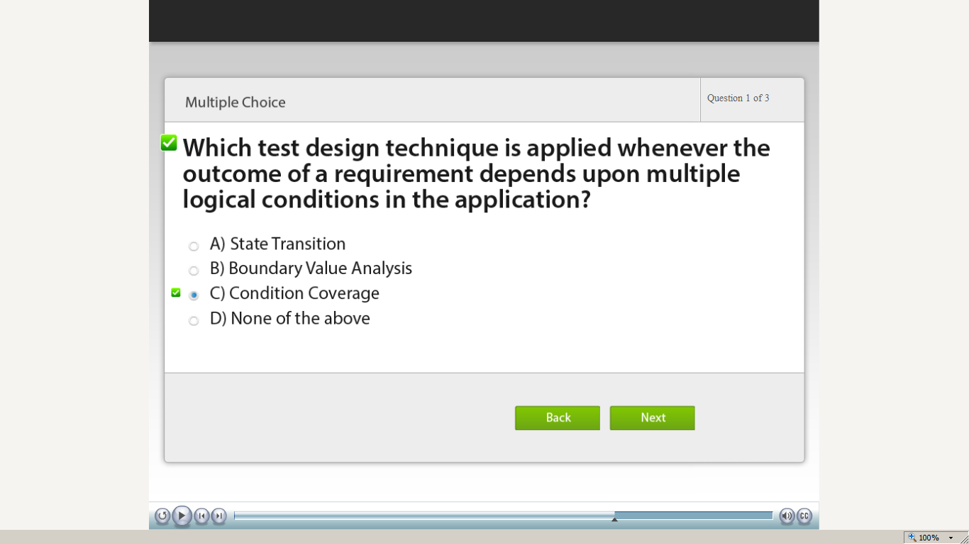](https://compass.learning.cognizant.com/elmprd/elearning/test_design_technique_condition_coverage/multiscreen.html)

[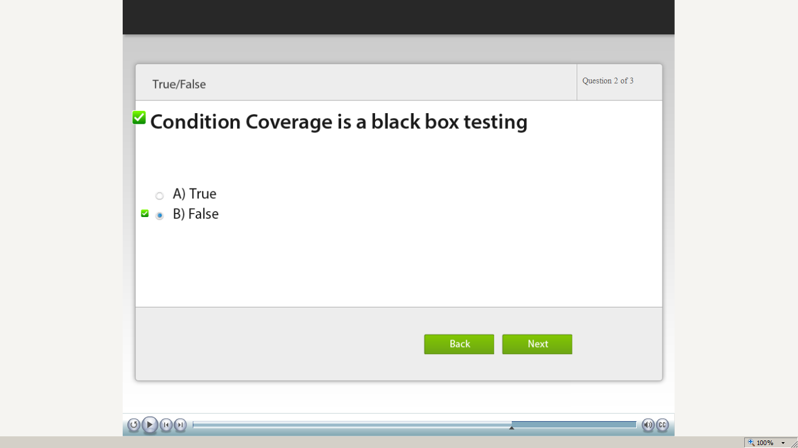](https://compass.learning.cognizant.com/elmprd/elearning/test_design_technique_condition_coverage/multiscreen.html)

[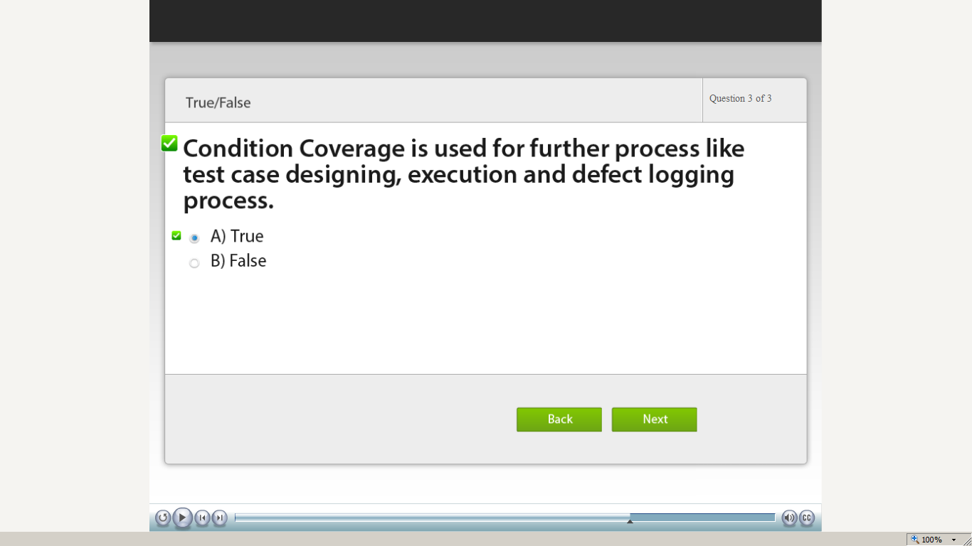](https://compass.learning.cognizant.com/elmprd/elearning/test_design_technique_condition_coverage/multiscreen.html)

[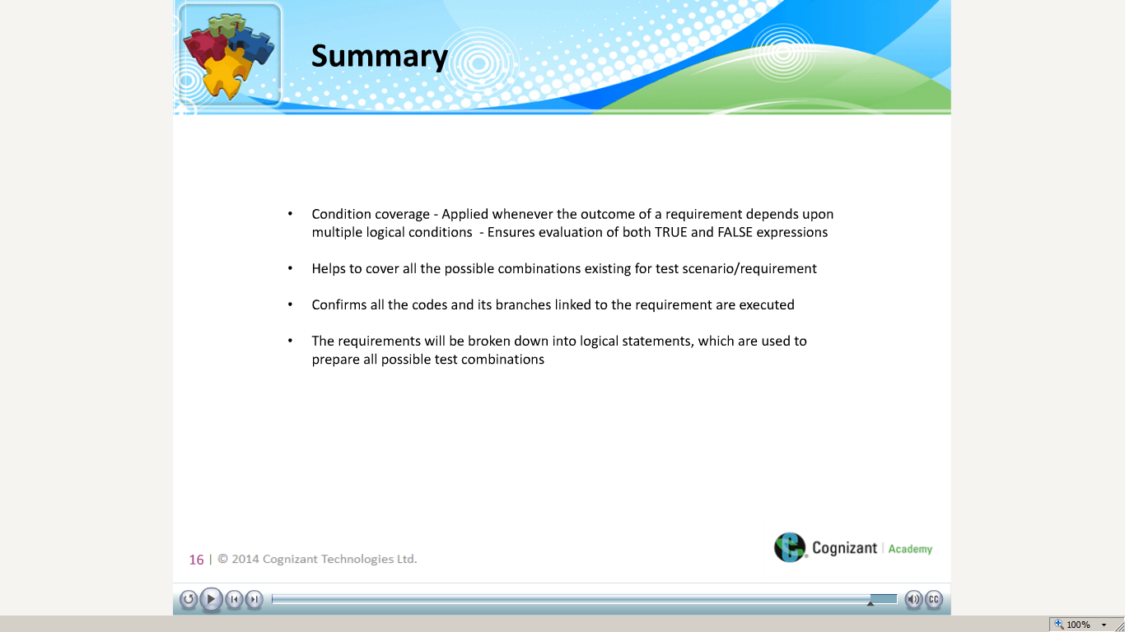](https://compass.learning.cognizant.com/elmprd/elearning/test_design_technique_condition_coverage/multiscreen.html)

Part 4

[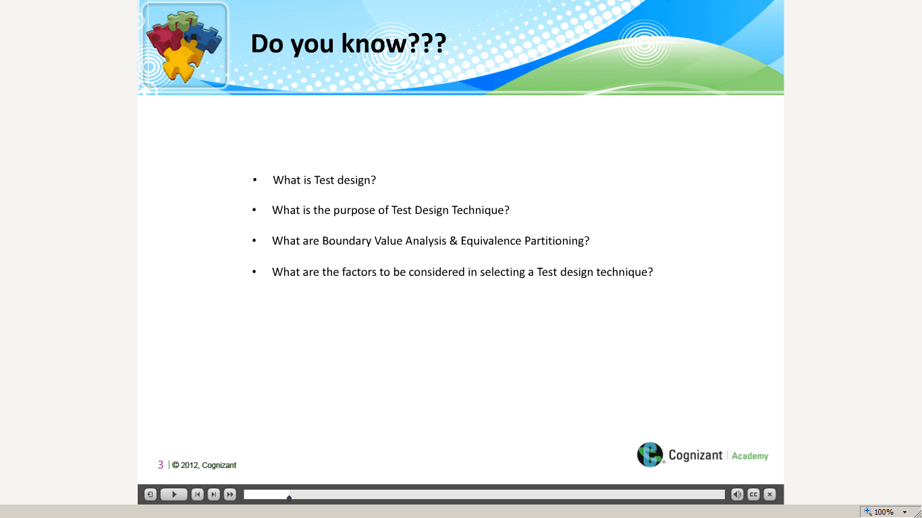](https://compass.learning.cognizant.com/elmprd/elearning/test_design_technique_exploratory_error_guessing_oct2014/multiscreen.html)

[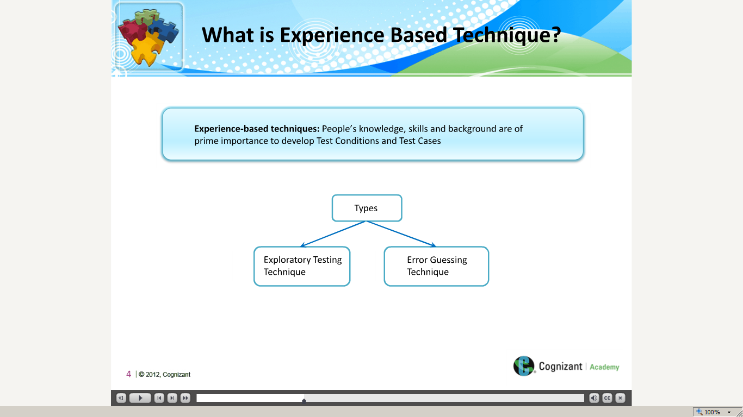](https://compass.learning.cognizant.com/elmprd/elearning/test_design_technique_exploratory_error_guessing_oct2014/multiscreen.html)

[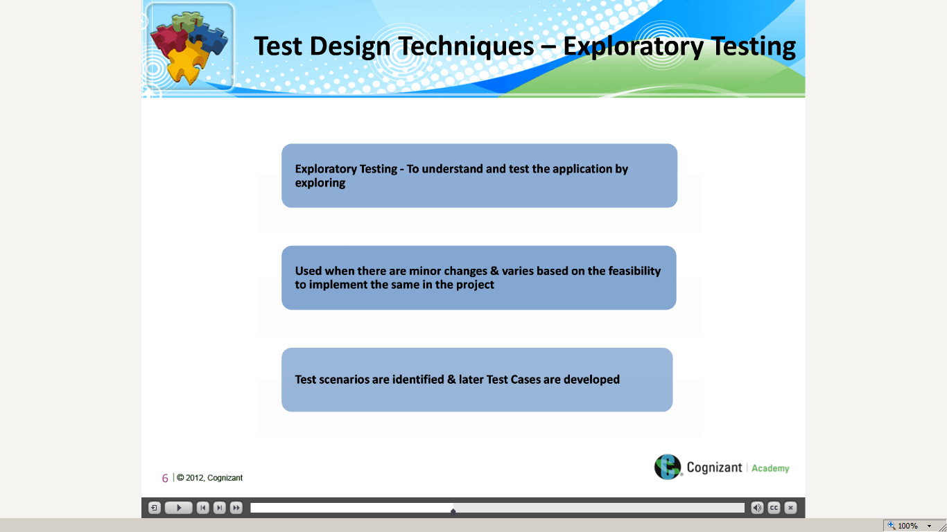](https://compass.learning.cognizant.com/elmprd/elearning/test_design_technique_exploratory_error_guessing_oct2014/multiscreen.html)

[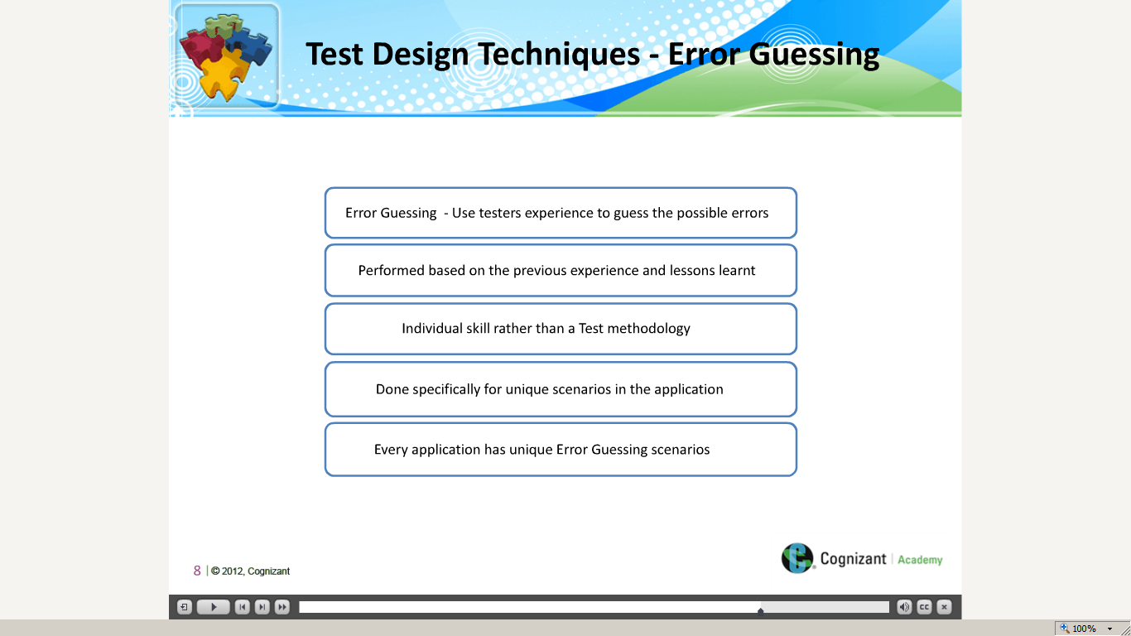](https://compass.learning.cognizant.com/elmprd/elearning/test_design_technique_exploratory_error_guessing_oct2014/multiscreen.html)

[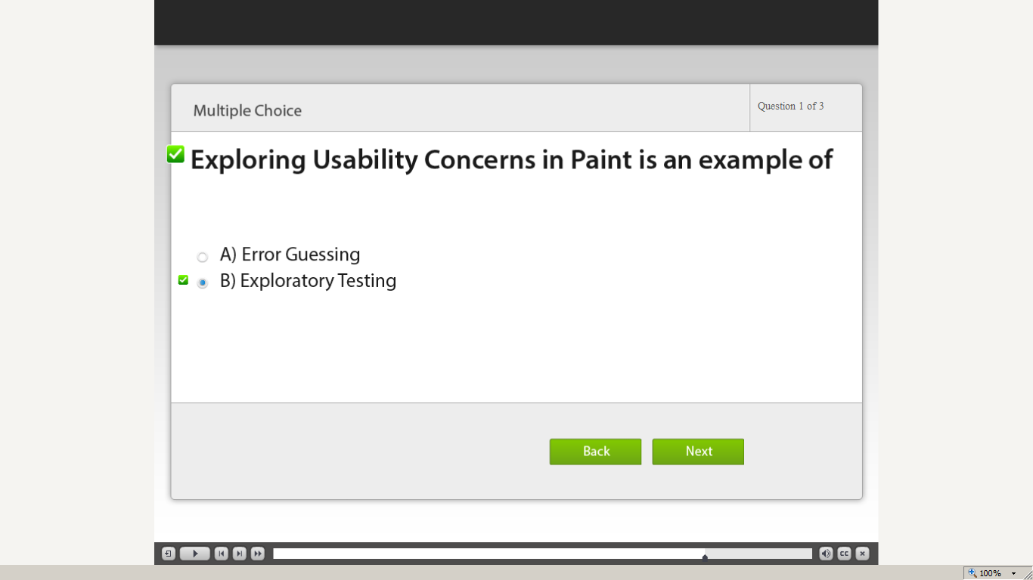](https://compass.learning.cognizant.com/elmprd/elearning/test_design_technique_exploratory_error_guessing_oct2014/multiscreen.html)

[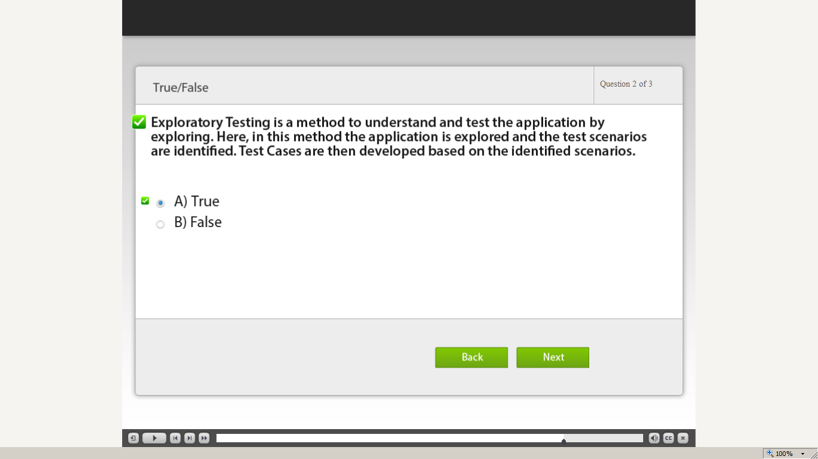](https://compass.learning.cognizant.com/elmprd/elearning/test_design_technique_exploratory_error_guessing_oct2014/multiscreen.html)

[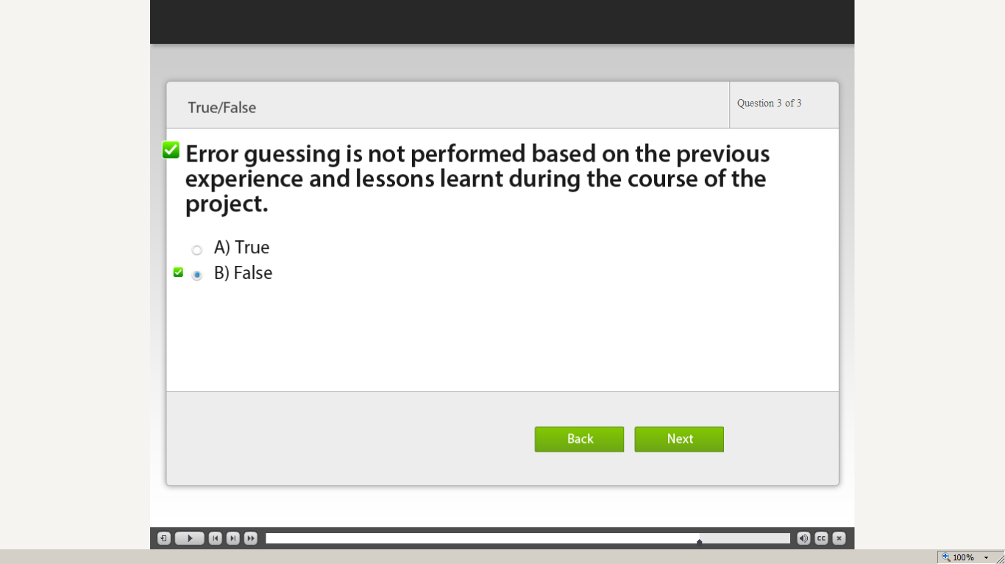](https://compass.learning.cognizant.com/elmprd/elearning/test_design_technique_exploratory_error_guessing_oct2014/multiscreen.html)

[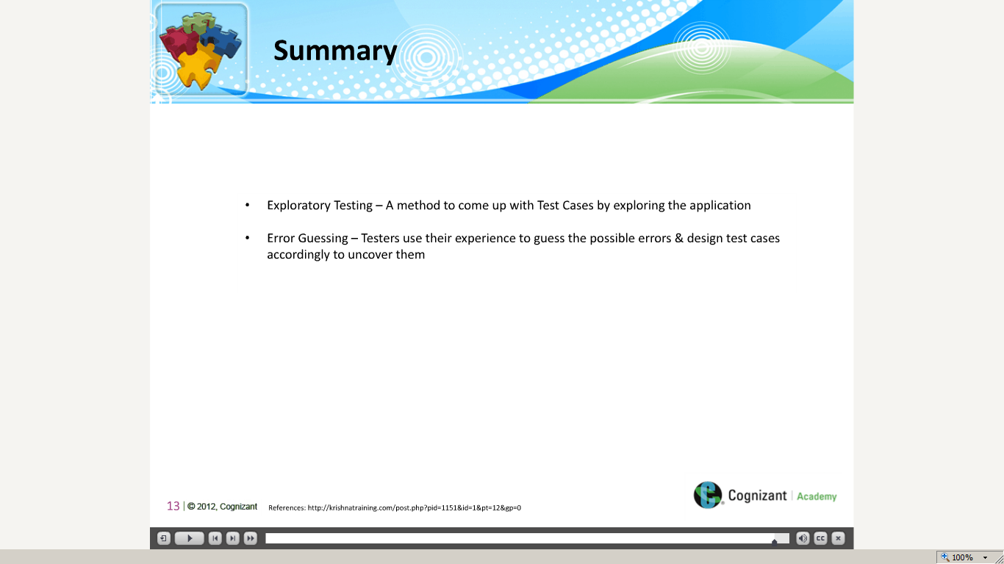](https://compass.learning.cognizant.com/elmprd/elearning/test_design_technique_exploratory_error_guessing_oct2014/multiscreen.html)

Part 5 a

[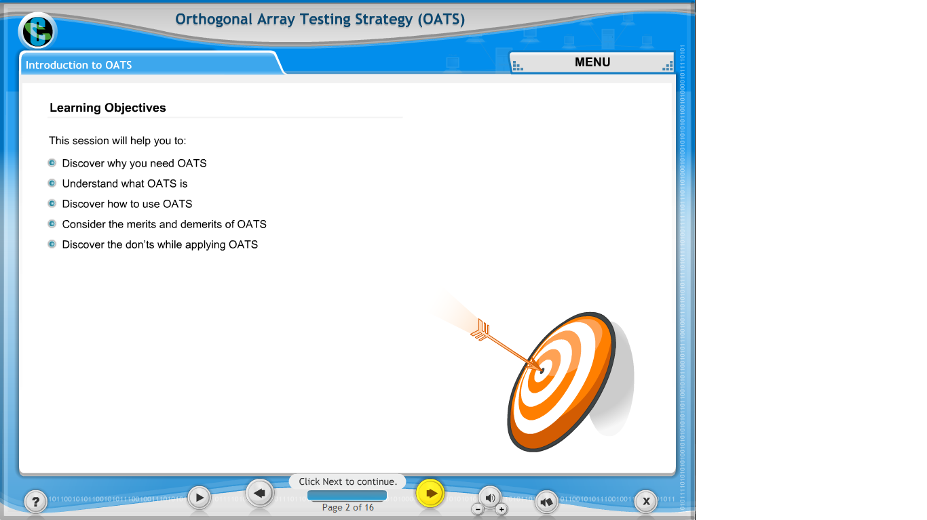](https://compass.learning.cognizant.com/elmprd/elearning/orthogonal_array_testing_strategy/introduction_to_oats/login.htm)

[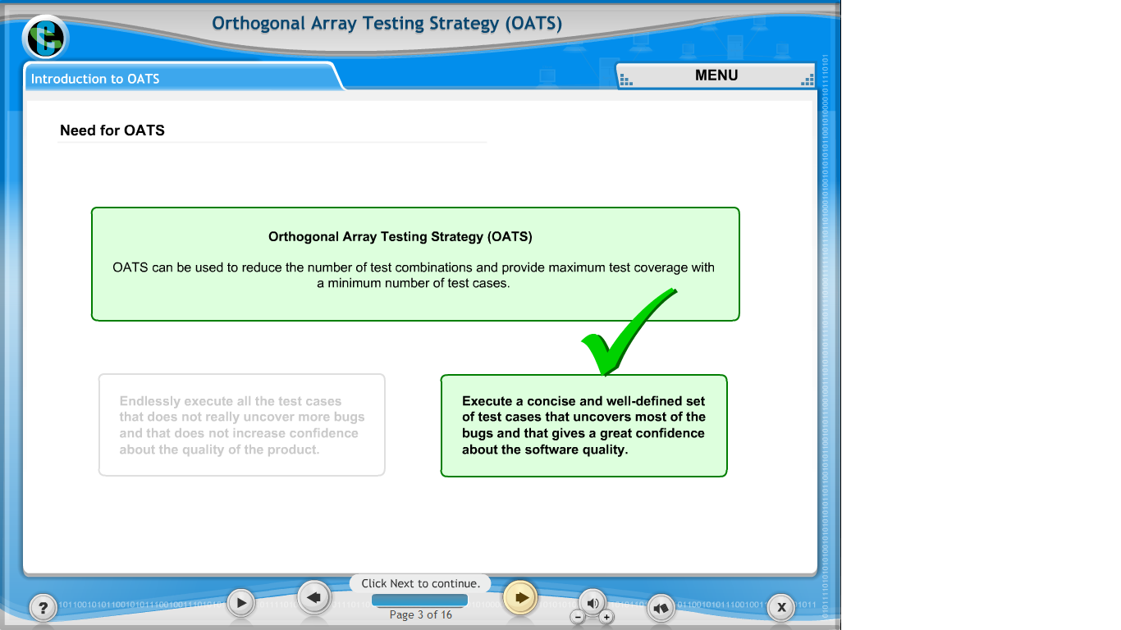](https://compass.learning.cognizant.com/elmprd/elearning/orthogonal_array_testing_strategy/introduction_to_oats/login.htm)

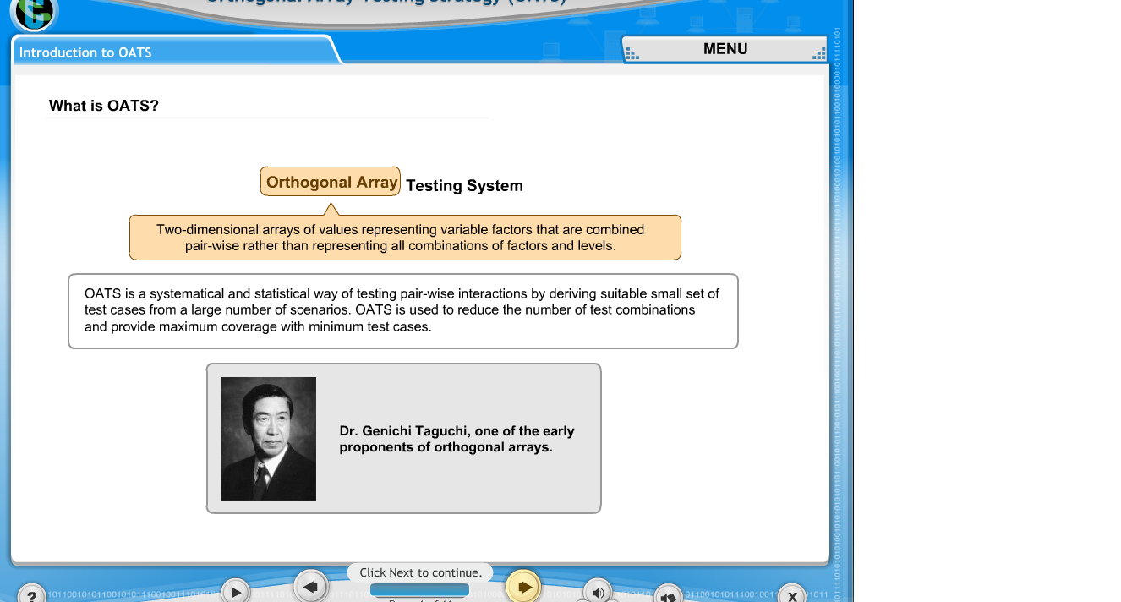

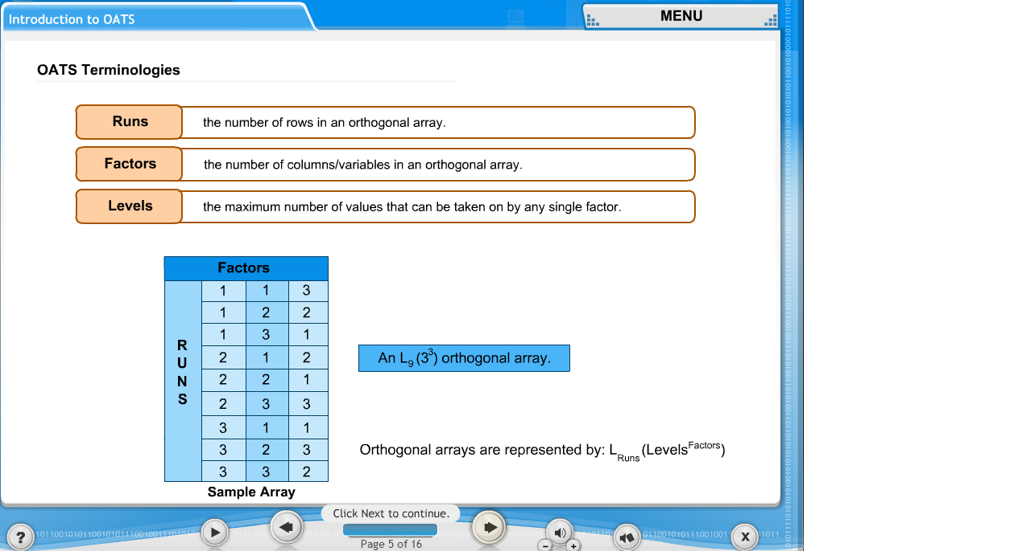

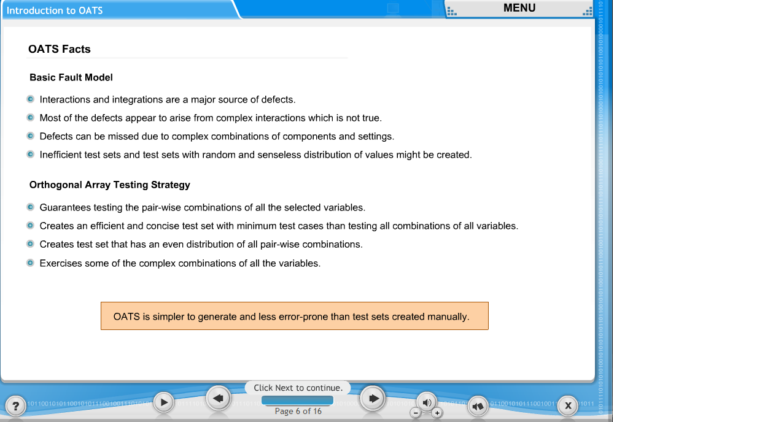

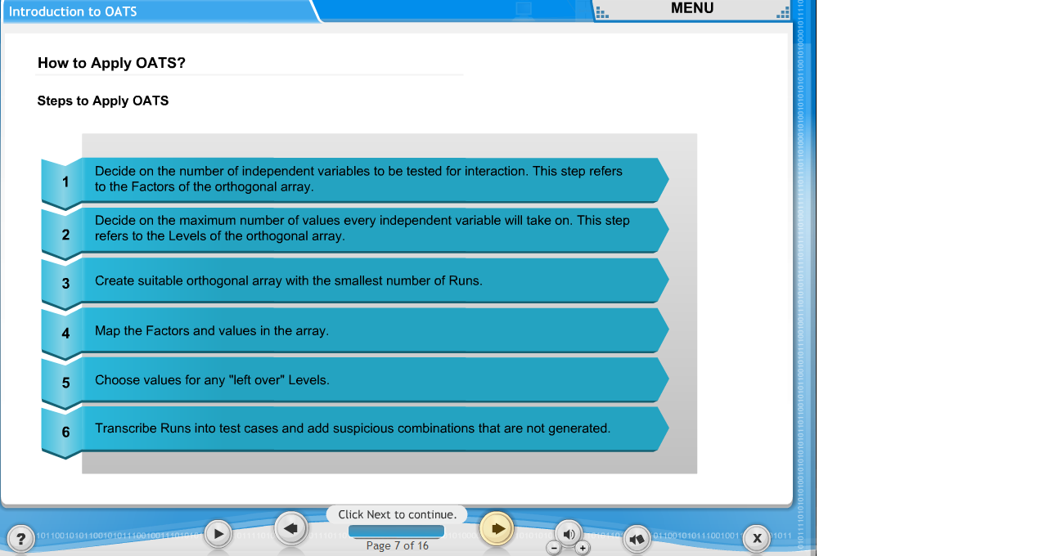

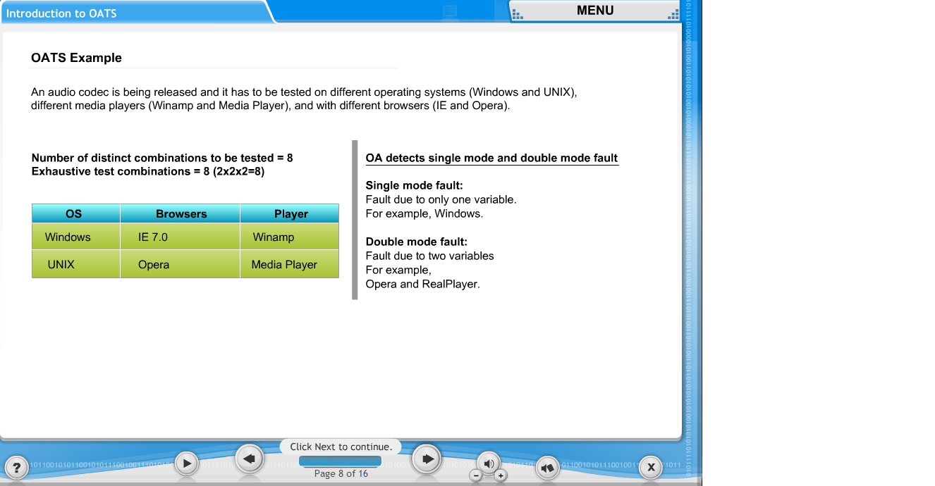

[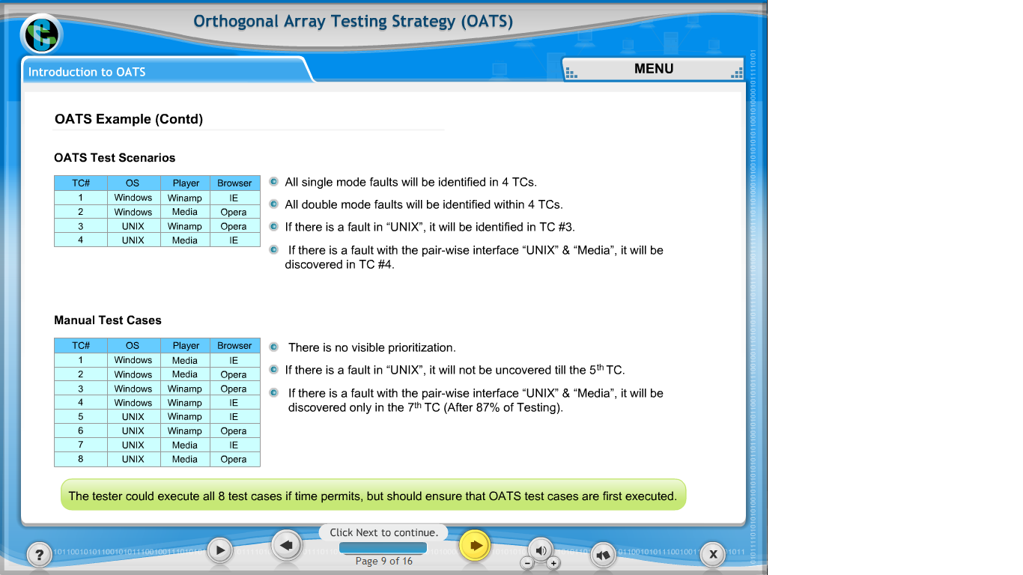](https://compass.learning.cognizant.com/elmprd/elearning/orthogonal_array_testing_strategy/introduction_to_oats/login.htm)

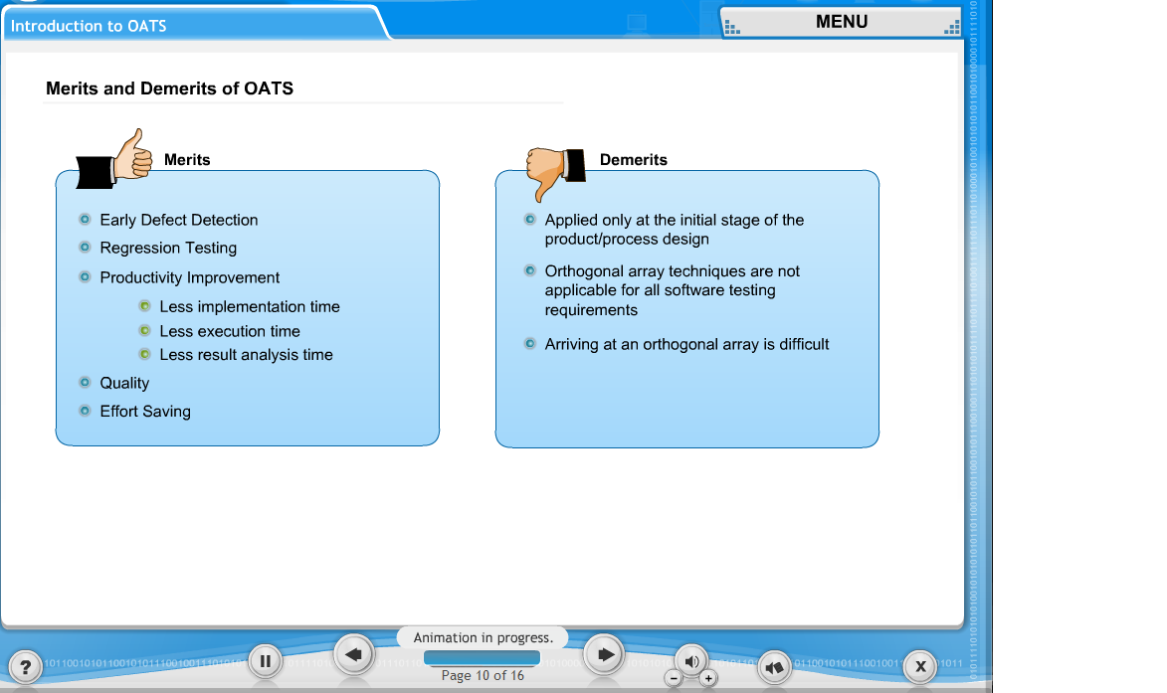

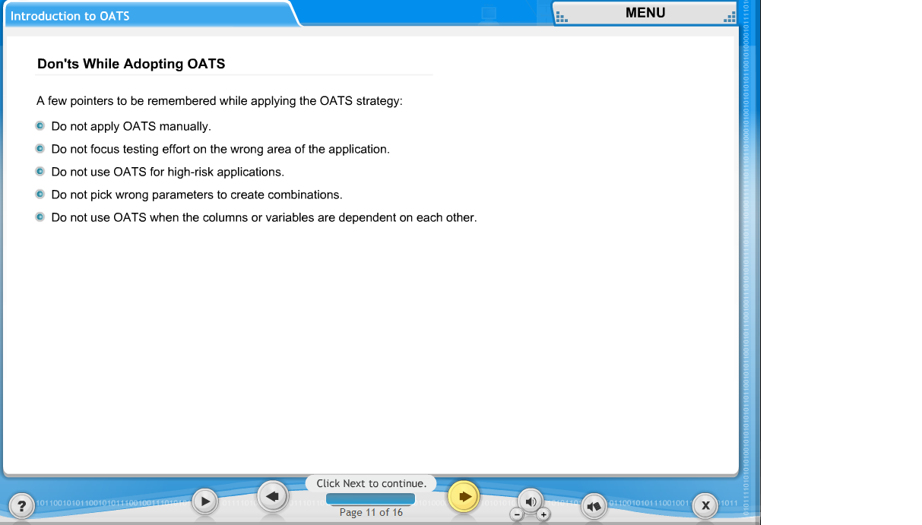

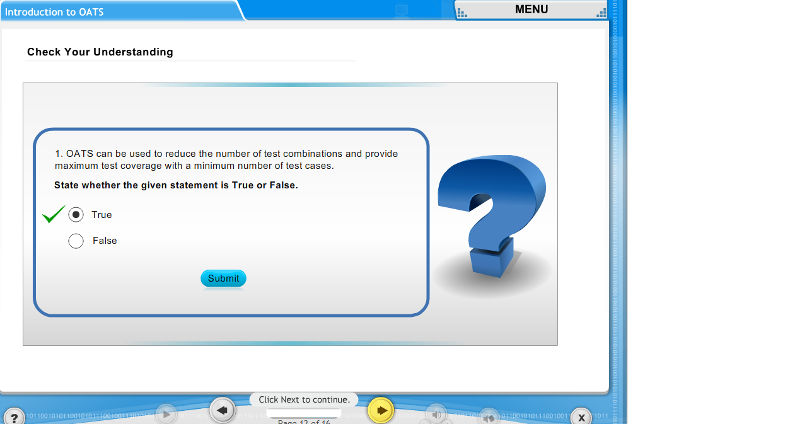

[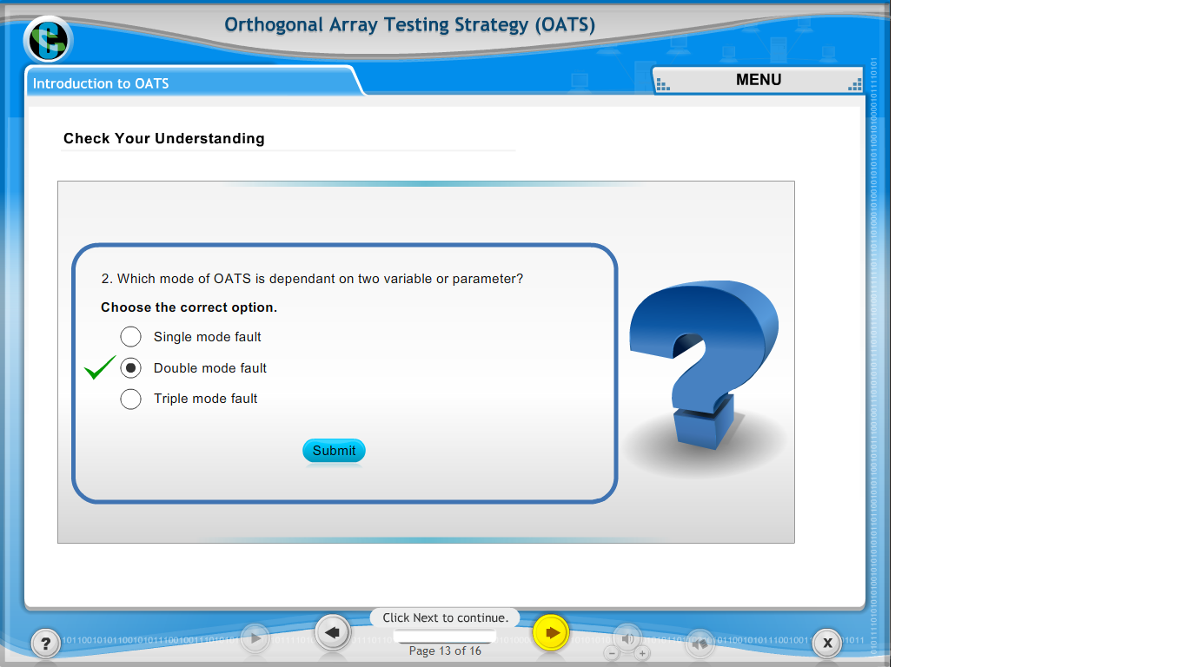](https://compass.learning.cognizant.com/elmprd/elearning/orthogonal_array_testing_strategy/introduction_to_oats/login.htm)

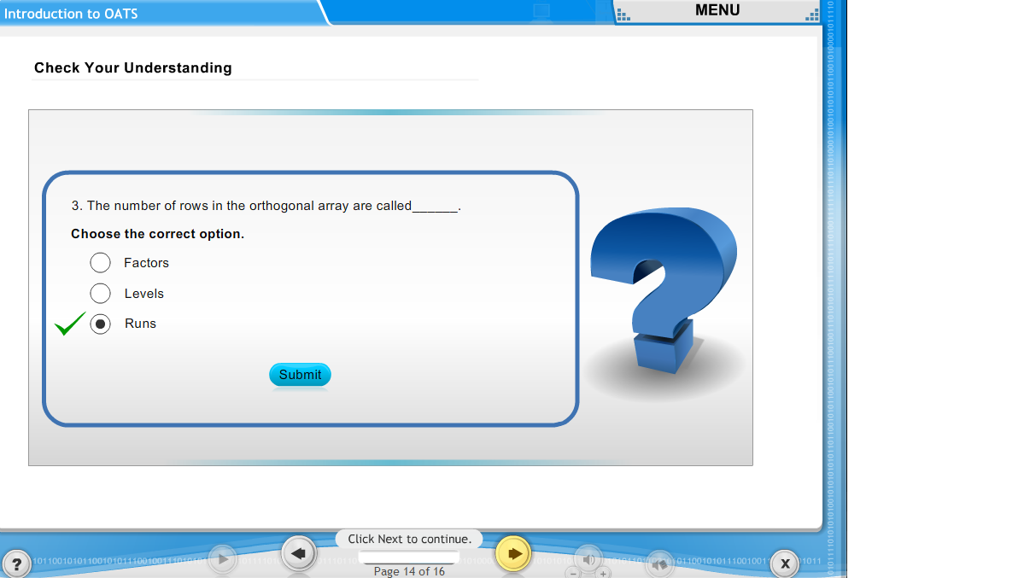

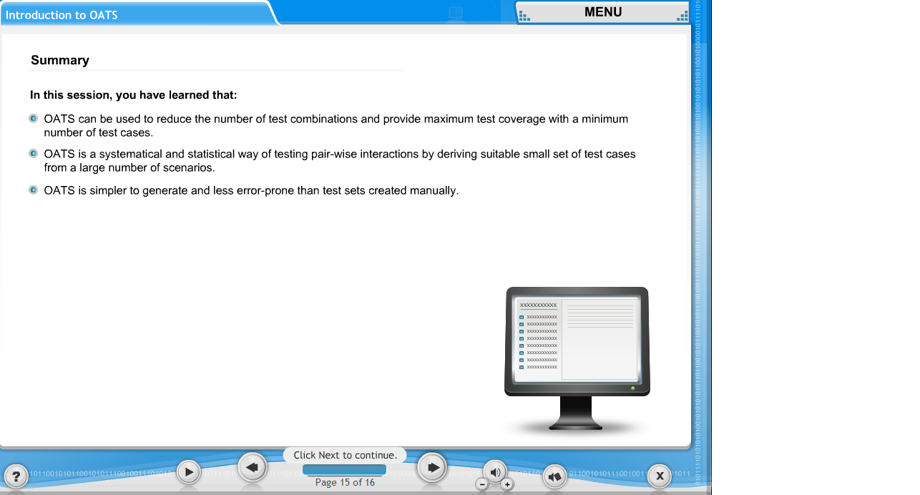

Part 5 b

[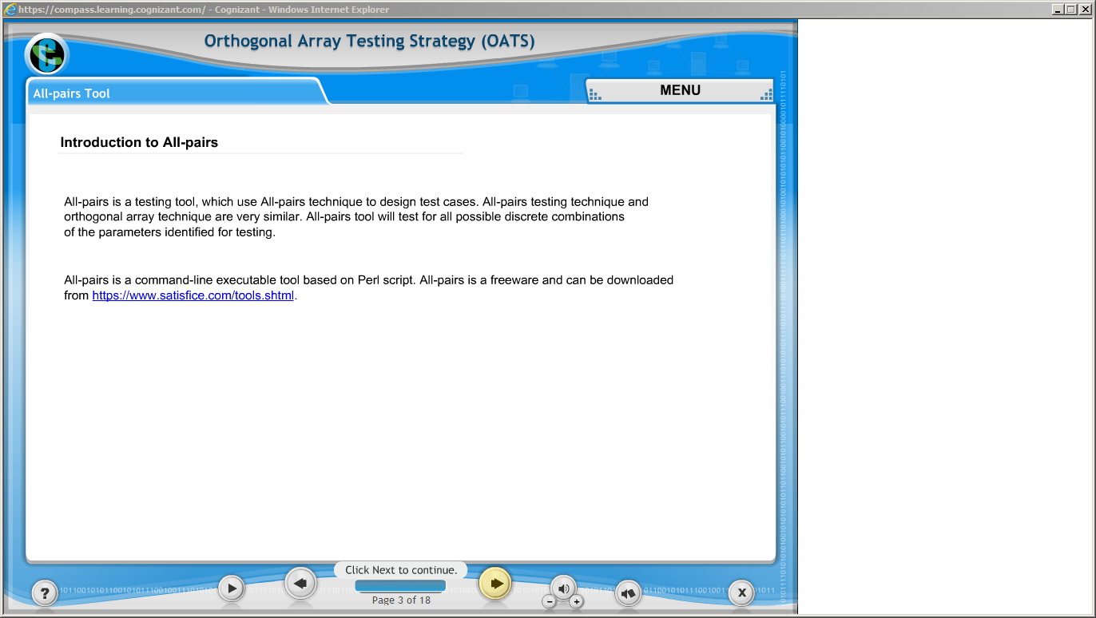](https://compass.learning.cognizant.com/elmprd/elearning/orthogonal_array_testing_strategy/all_pairs_tool/login.htm)

[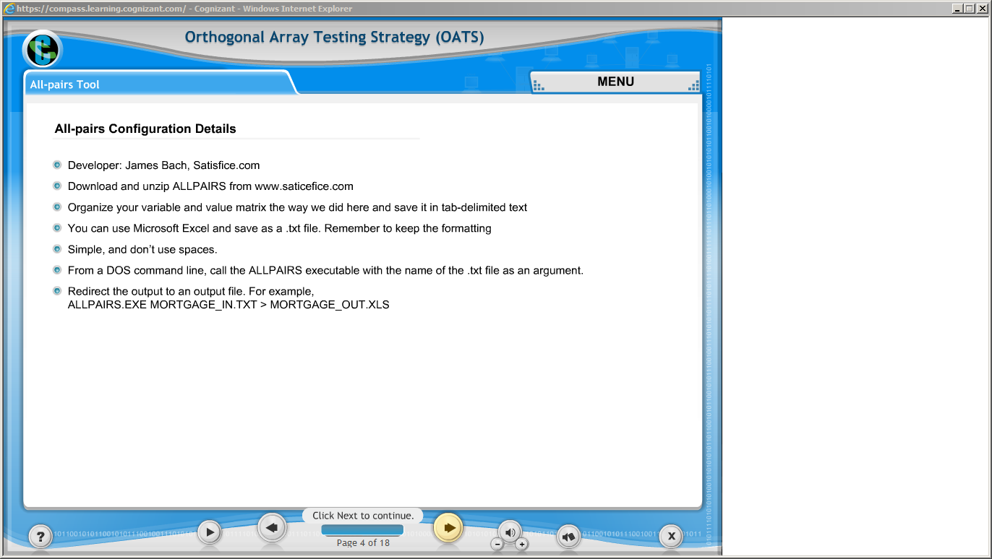](https://compass.learning.cognizant.com/elmprd/elearning/orthogonal_array_testing_strategy/all_pairs_tool/login.htm)

[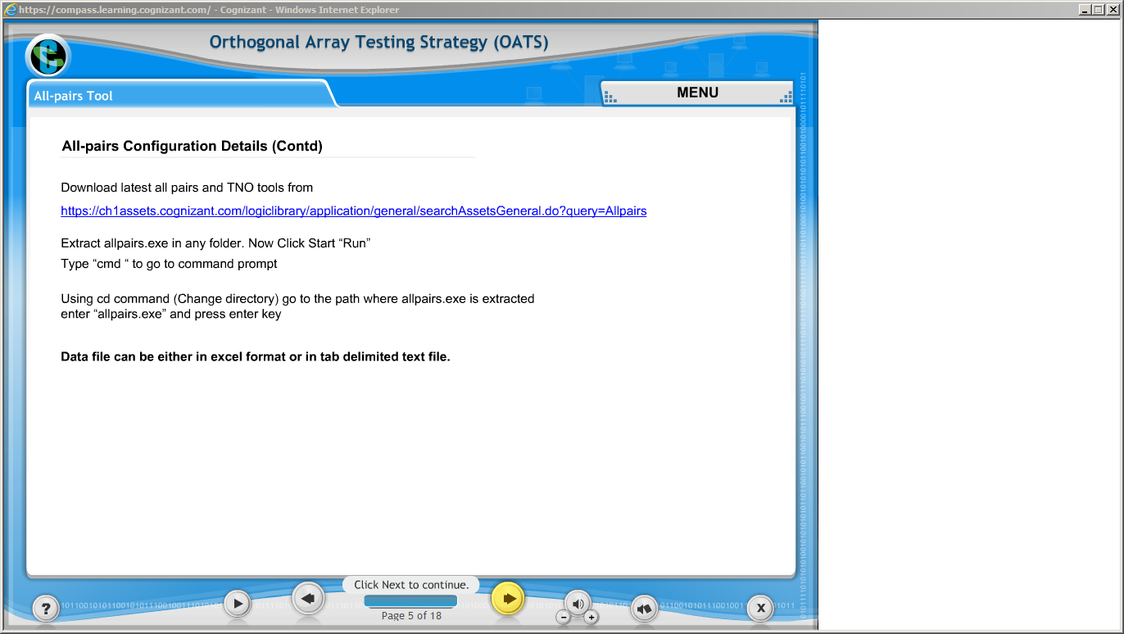](https://compass.learning.cognizant.com/elmprd/elearning/orthogonal_array_testing_strategy/all_pairs_tool/login.htm)

[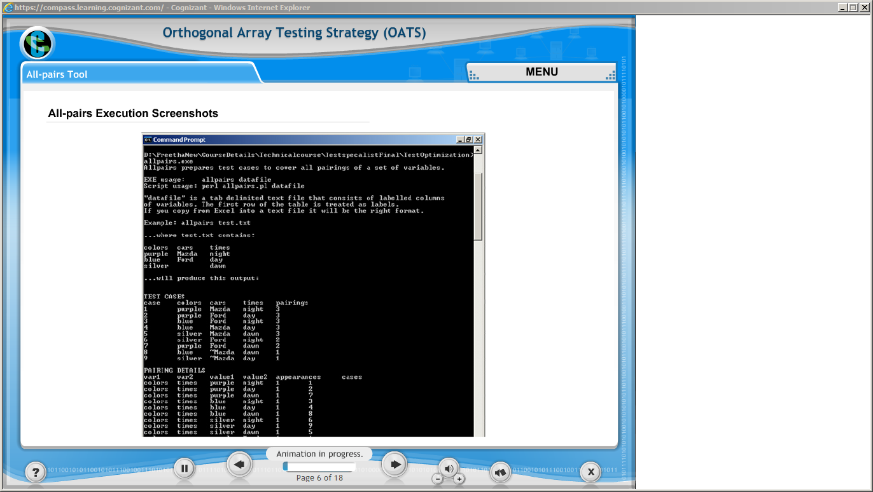](https://compass.learning.cognizant.com/elmprd/elearning/orthogonal_array_testing_strategy/all_pairs_tool/login.htm)

[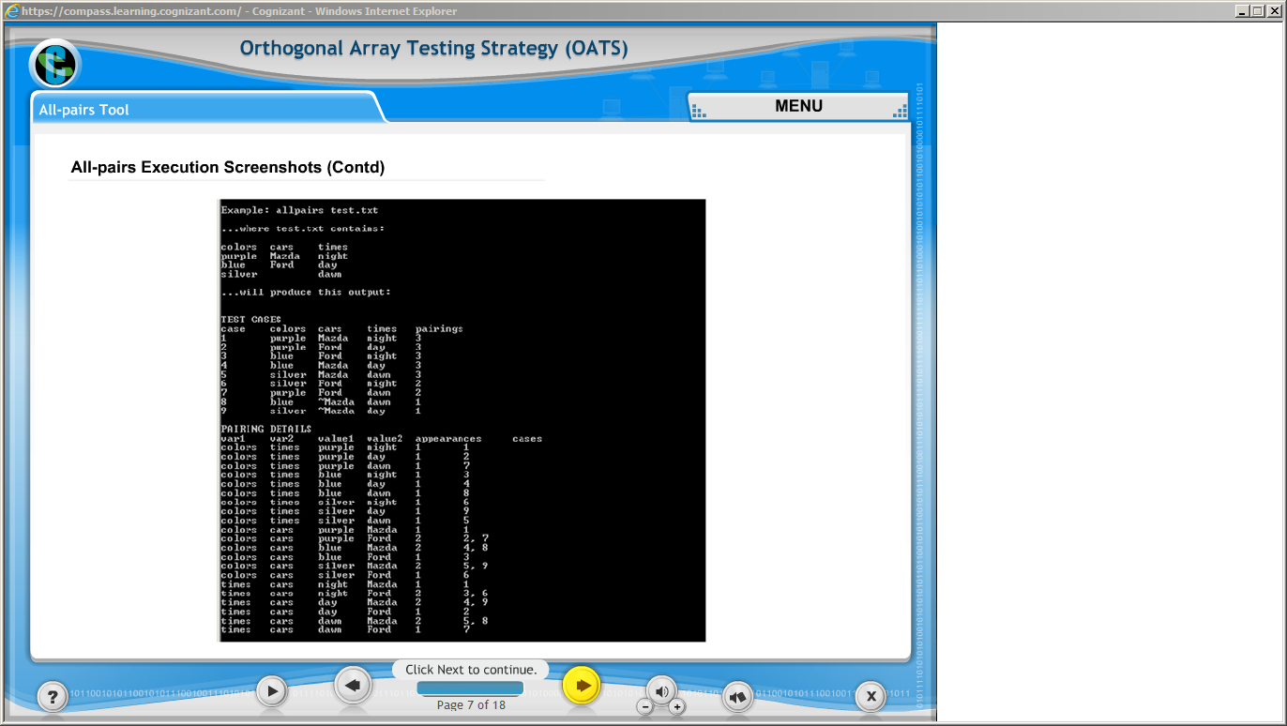](https://compass.learning.cognizant.com/elmprd/elearning/orthogonal_array_testing_strategy/all_pairs_tool/login.htm)

[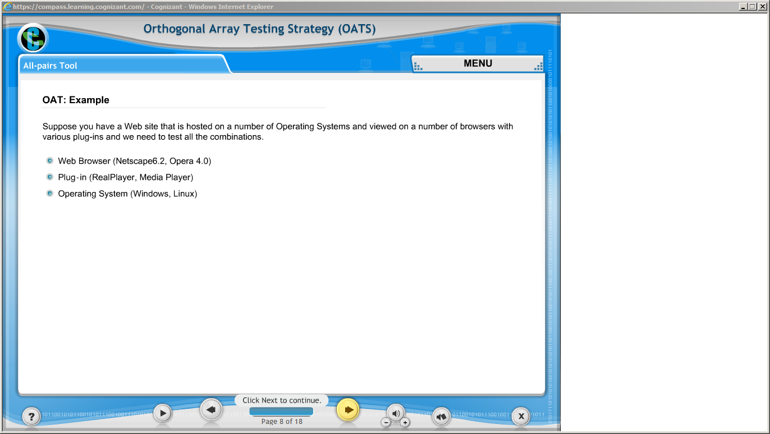](https://compass.learning.cognizant.com/elmprd/elearning/orthogonal_array_testing_strategy/all_pairs_tool/login.htm)

[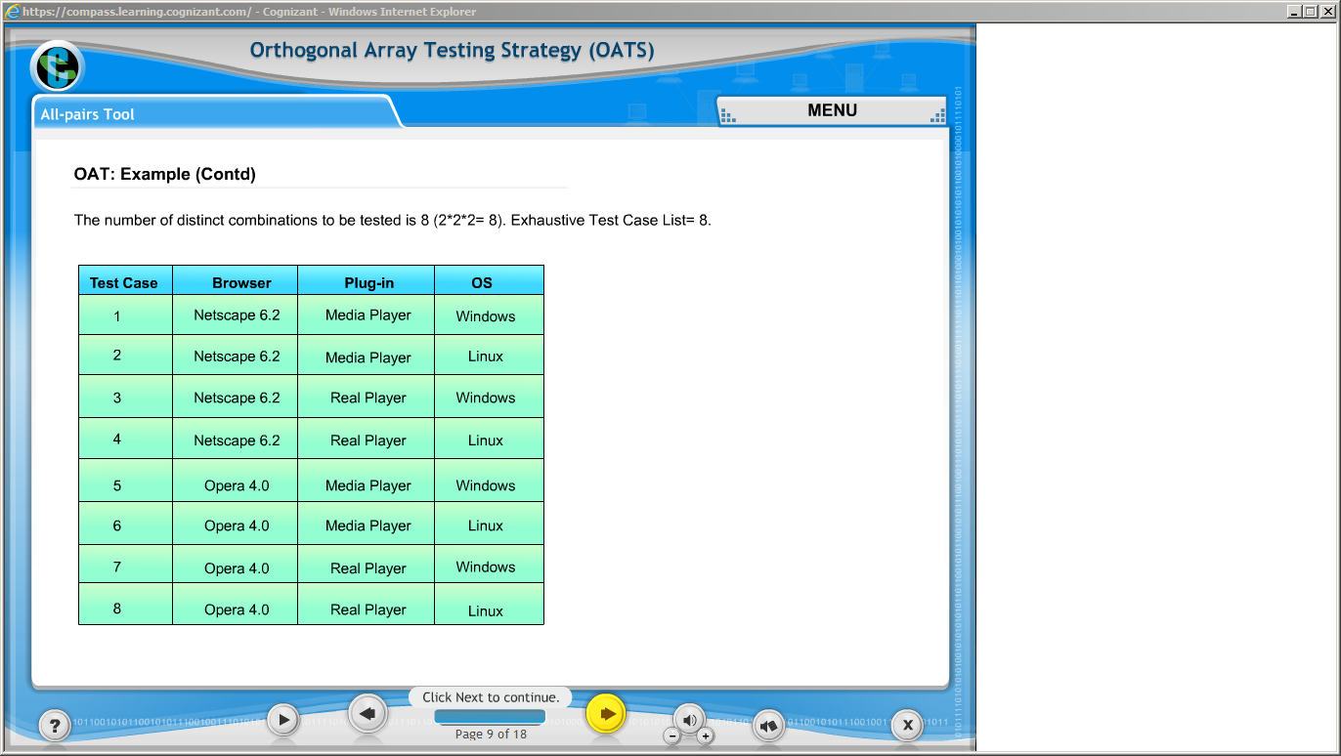](https://compass.learning.cognizant.com/elmprd/elearning/orthogonal_array_testing_strategy/all_pairs_tool/login.htm)

[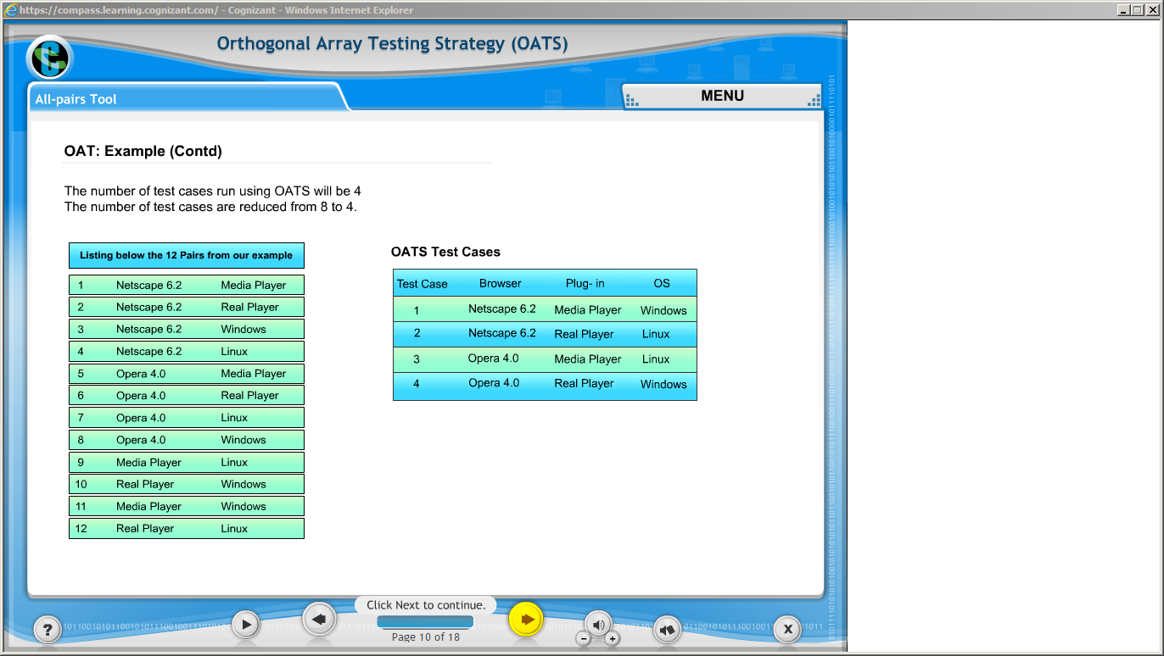](https://compass.learning.cognizant.com/elmprd/elearning/orthogonal_array_testing_strategy/all_pairs_tool/login.htm)

[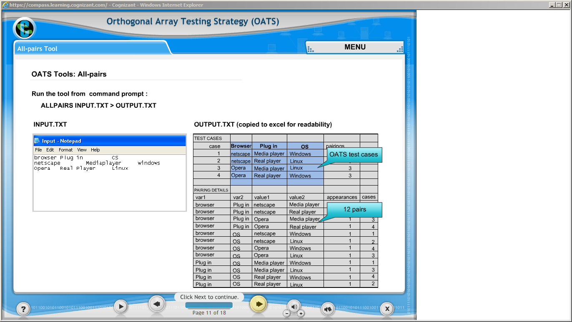](https://compass.learning.cognizant.com/elmprd/elearning/orthogonal_array_testing_strategy/all_pairs_tool/login.htm)

[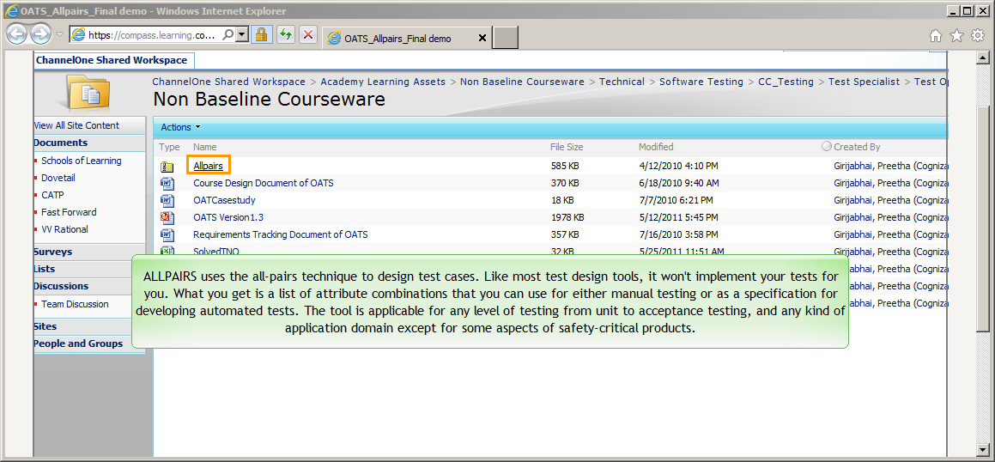](https://compass.learning.cognizant.com/elmprd/elearning/orthogonal_array_testing_strategy/attachments/allpairs_pg12/oats_allpairs_final%20demo.htm)

[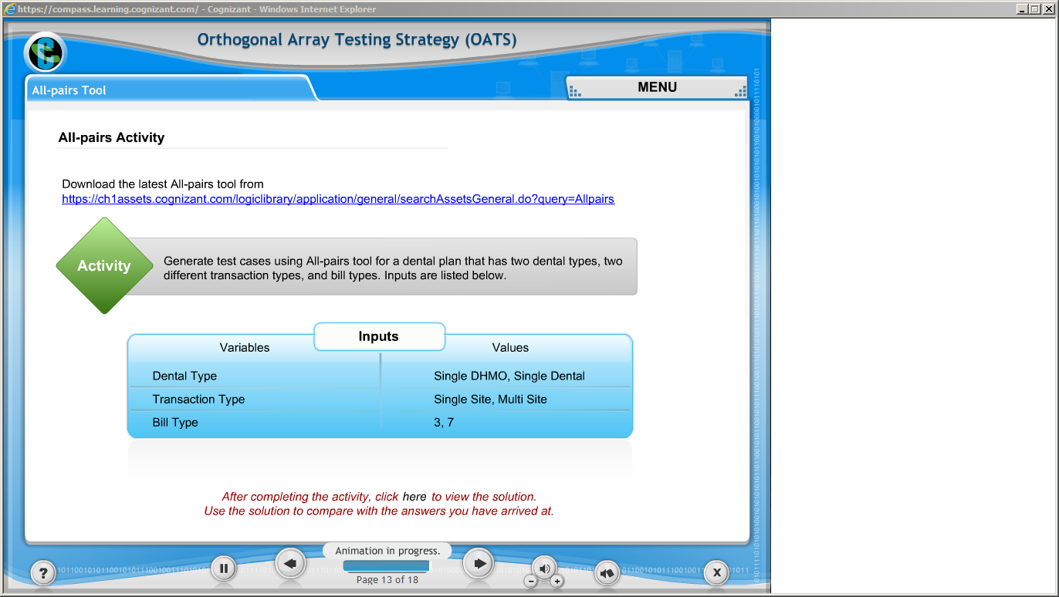](https://compass.learning.cognizant.com/elmprd/elearning/orthogonal_array_testing_strategy/all_pairs_tool/login.htm)

[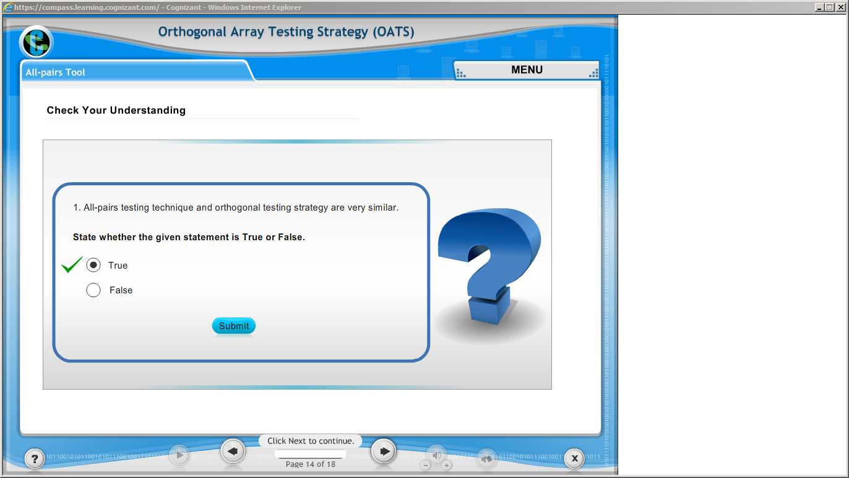](https://compass.learning.cognizant.com/elmprd/elearning/orthogonal_array_testing_strategy/all_pairs_tool/login.htm)

[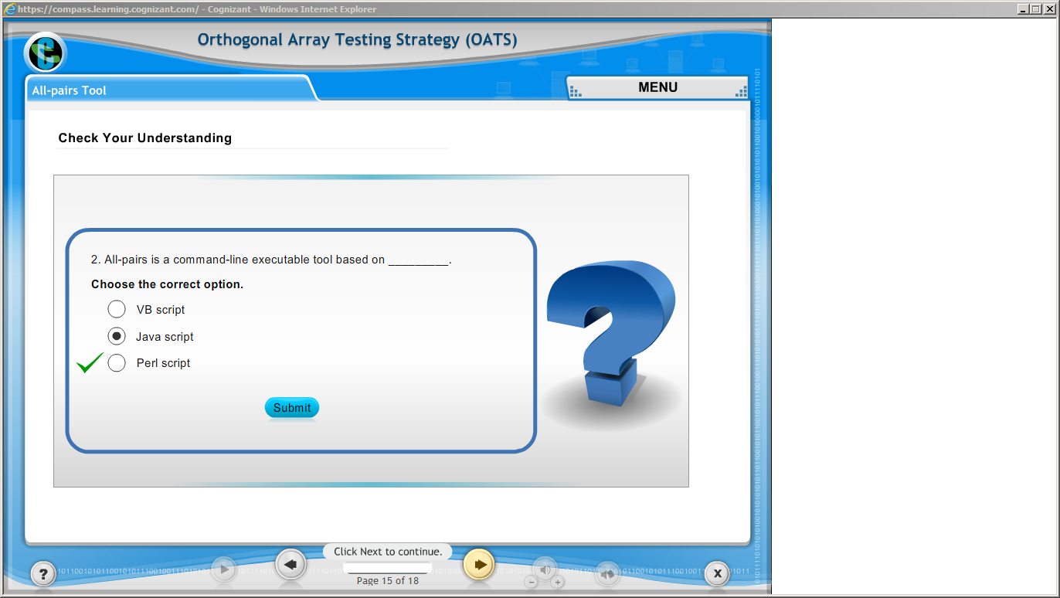](https://compass.learning.cognizant.com/elmprd/elearning/orthogonal_array_testing_strategy/all_pairs_tool/login.htm)

[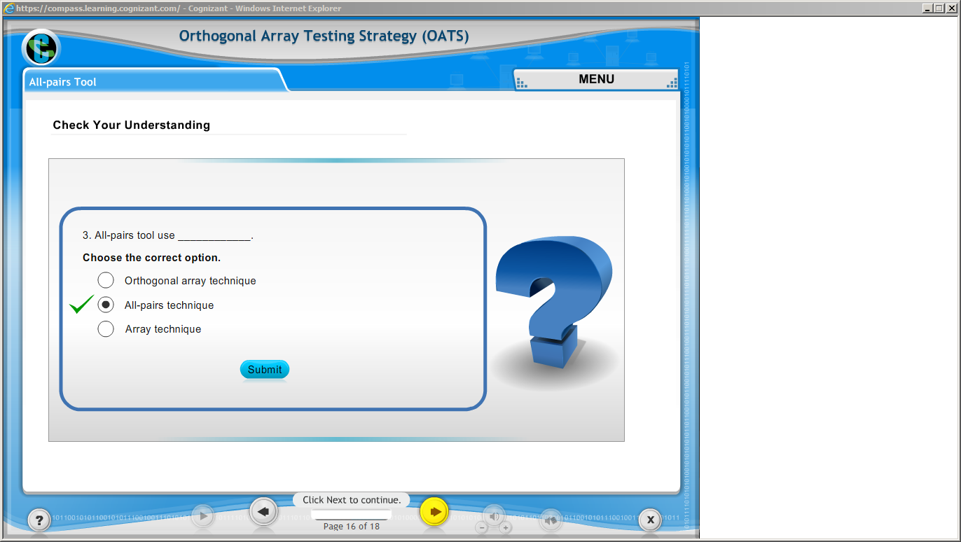](https://compass.learning.cognizant.com/elmprd/elearning/orthogonal_array_testing_strategy/all_pairs_tool/login.htm)

[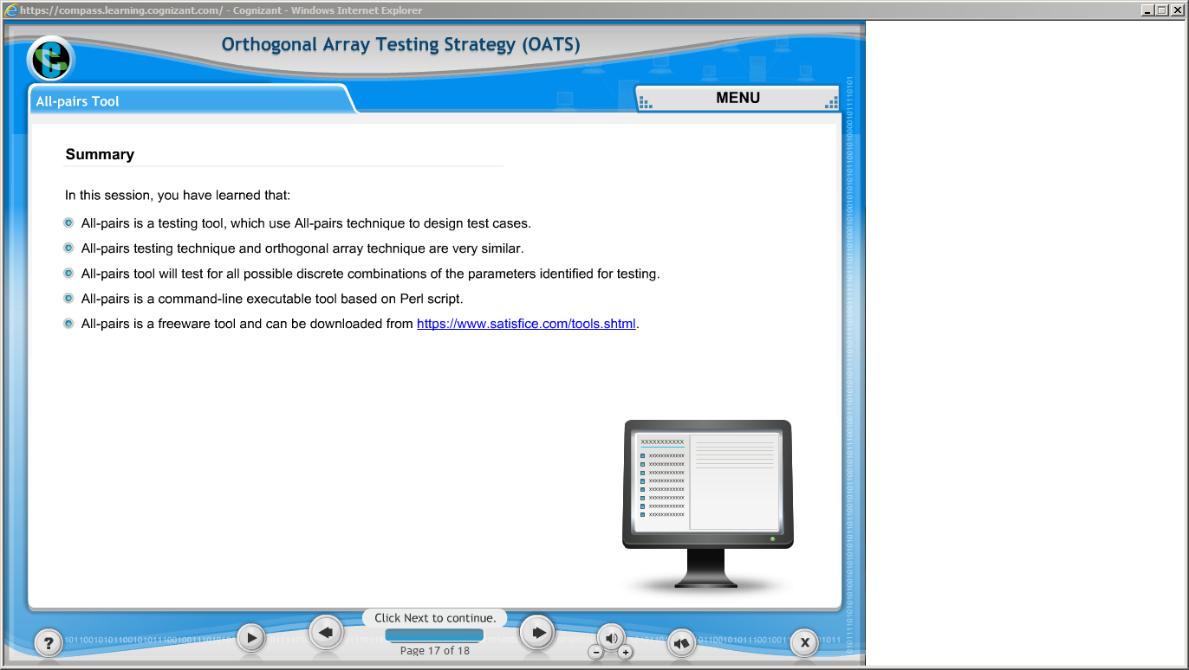](https://compass.learning.cognizant.com/elmprd/elearning/orthogonal_array_testing_strategy/all_pairs_tool/login.htm)

Part 5 c

[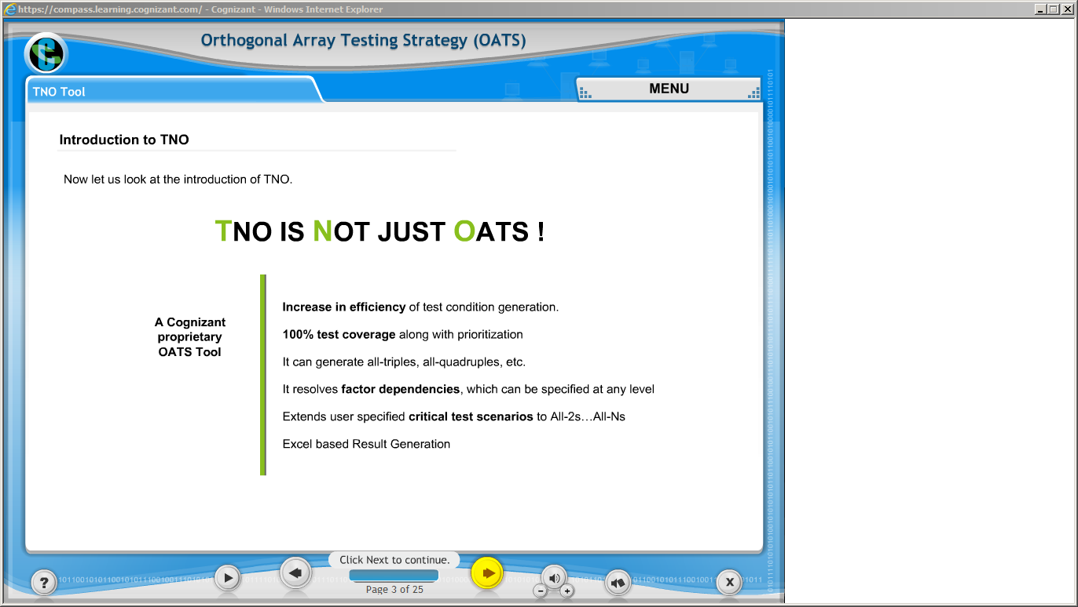](https://compass.learning.cognizant.com/elmprd/elearning/orthogonal_array_testing_strategy/tno_tool/login.htm)

[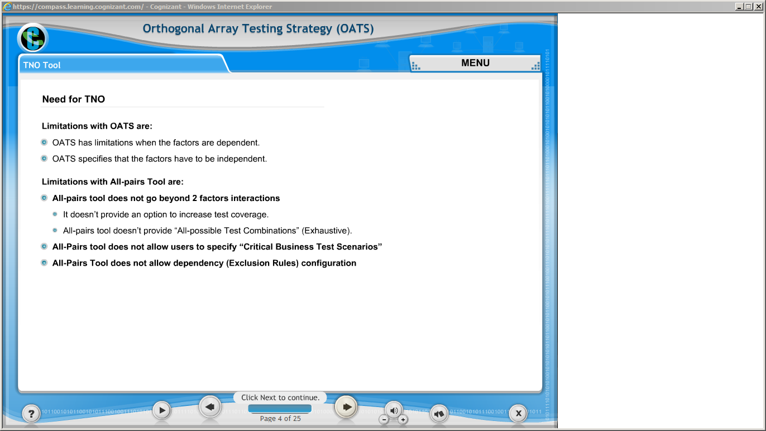](https://compass.learning.cognizant.com/elmprd/elearning/orthogonal_array_testing_strategy/tno_tool/login.htm)

[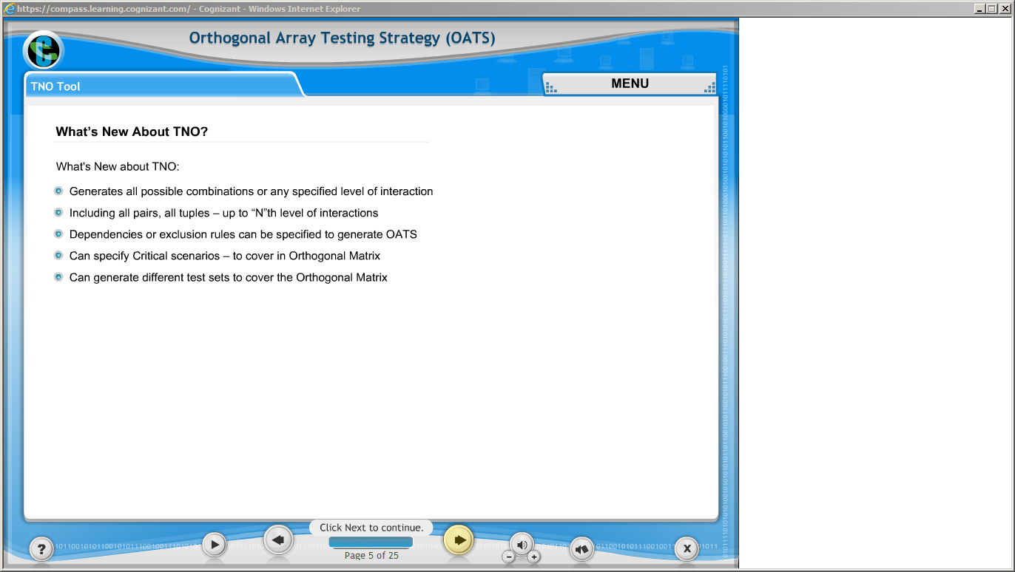](https://compass.learning.cognizant.com/elmprd/elearning/orthogonal_array_testing_strategy/tno_tool/login.htm)

[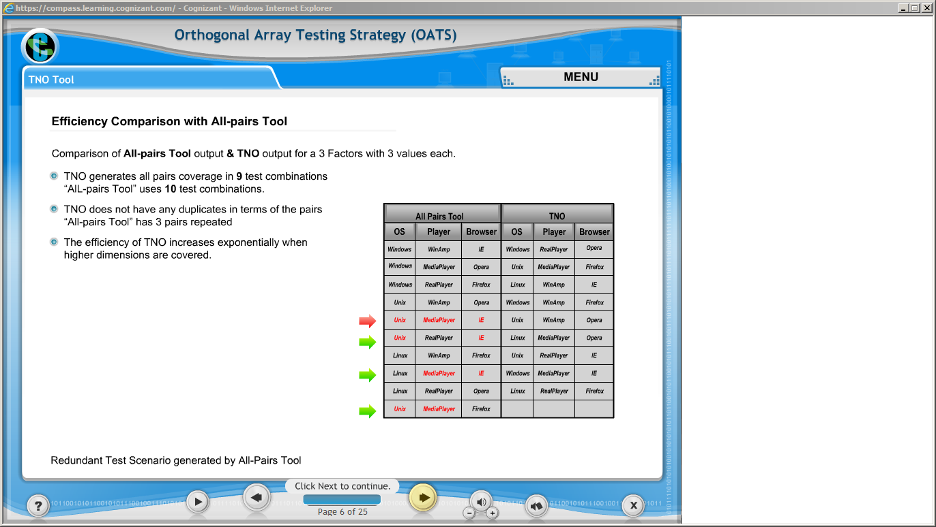](https://compass.learning.cognizant.com/elmprd/elearning/orthogonal_array_testing_strategy/tno_tool/login.htm)

[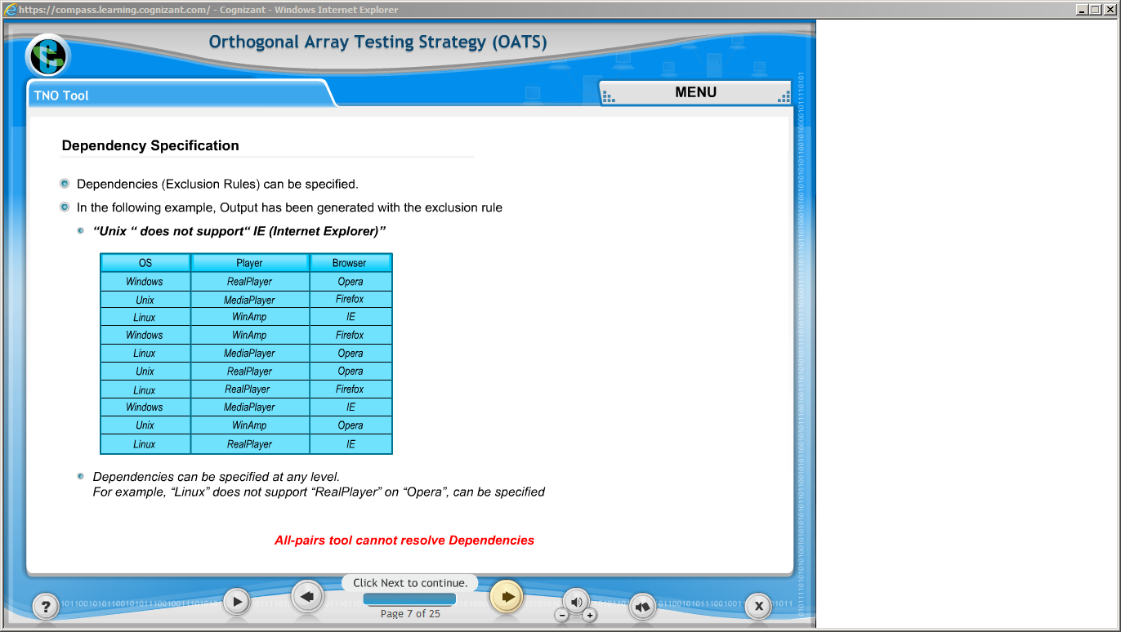](https://compass.learning.cognizant.com/elmprd/elearning/orthogonal_array_testing_strategy/tno_tool/login.htm)

[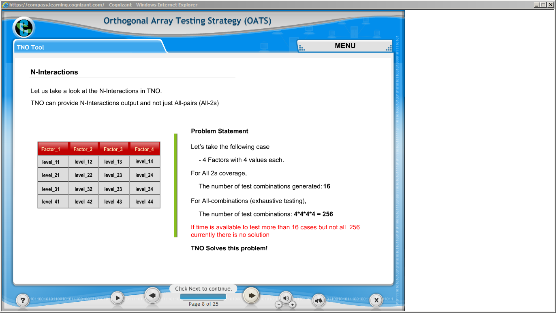](https://compass.learning.cognizant.com/elmprd/elearning/orthogonal_array_testing_strategy/tno_tool/login.htm)

[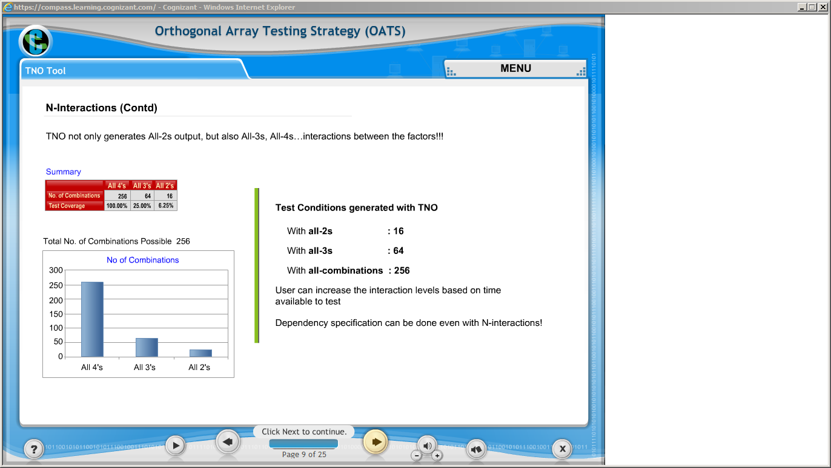](https://compass.learning.cognizant.com/elmprd/elearning/orthogonal_array_testing_strategy/tno_tool/login.htm)

[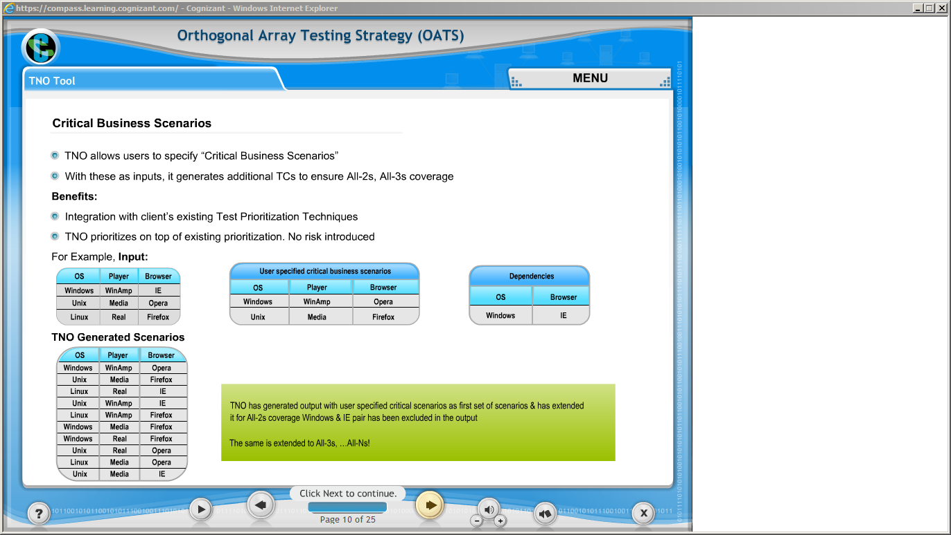](https://compass.learning.cognizant.com/elmprd/elearning/orthogonal_array_testing_strategy/tno_tool/login.htm)

[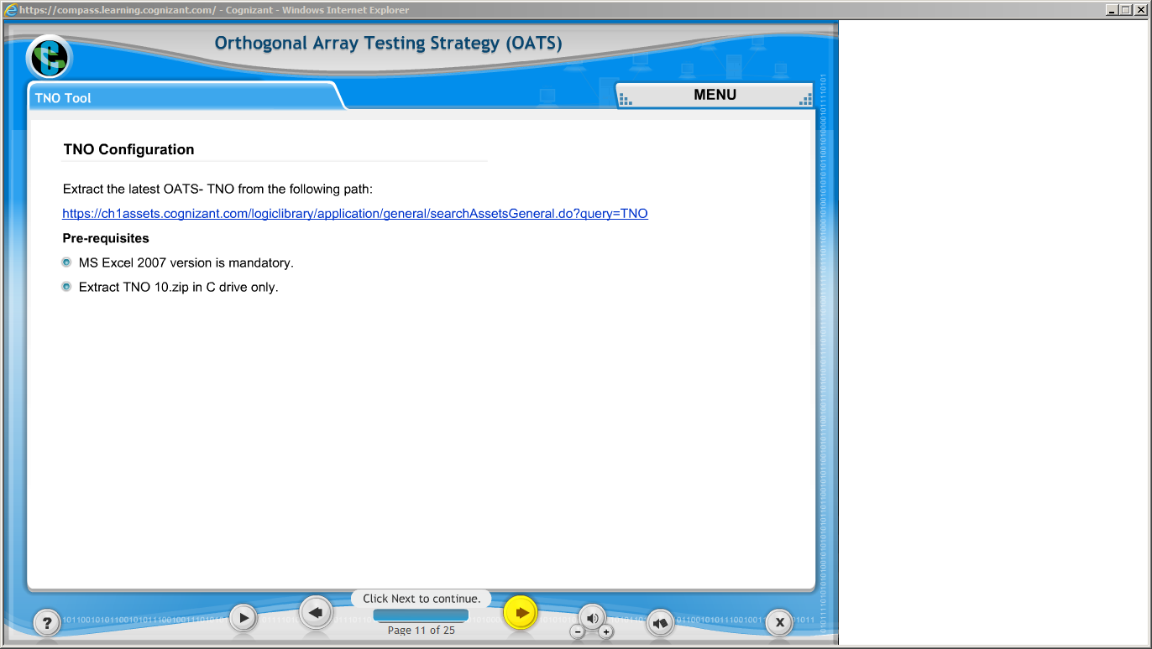](https://compass.learning.cognizant.com/elmprd/elearning/orthogonal_array_testing_strategy/tno_tool/login.htm)

[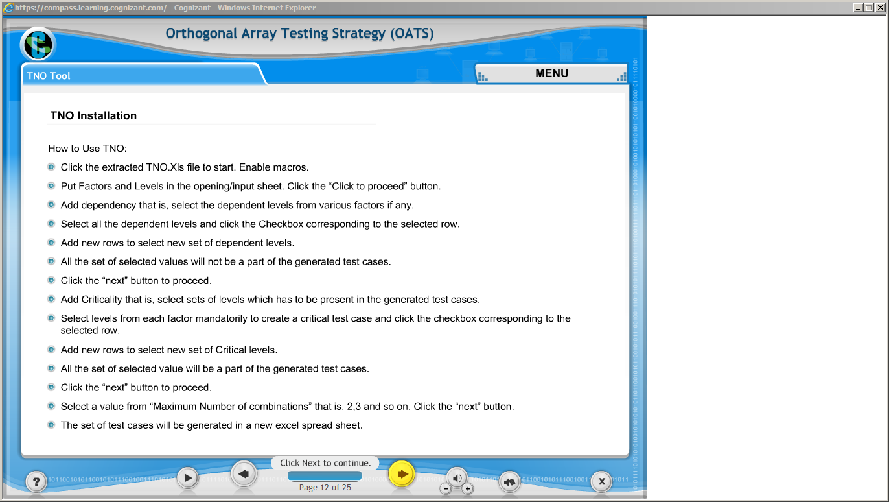](https://compass.learning.cognizant.com/elmprd/elearning/orthogonal_array_testing_strategy/tno_tool/login.htm)

[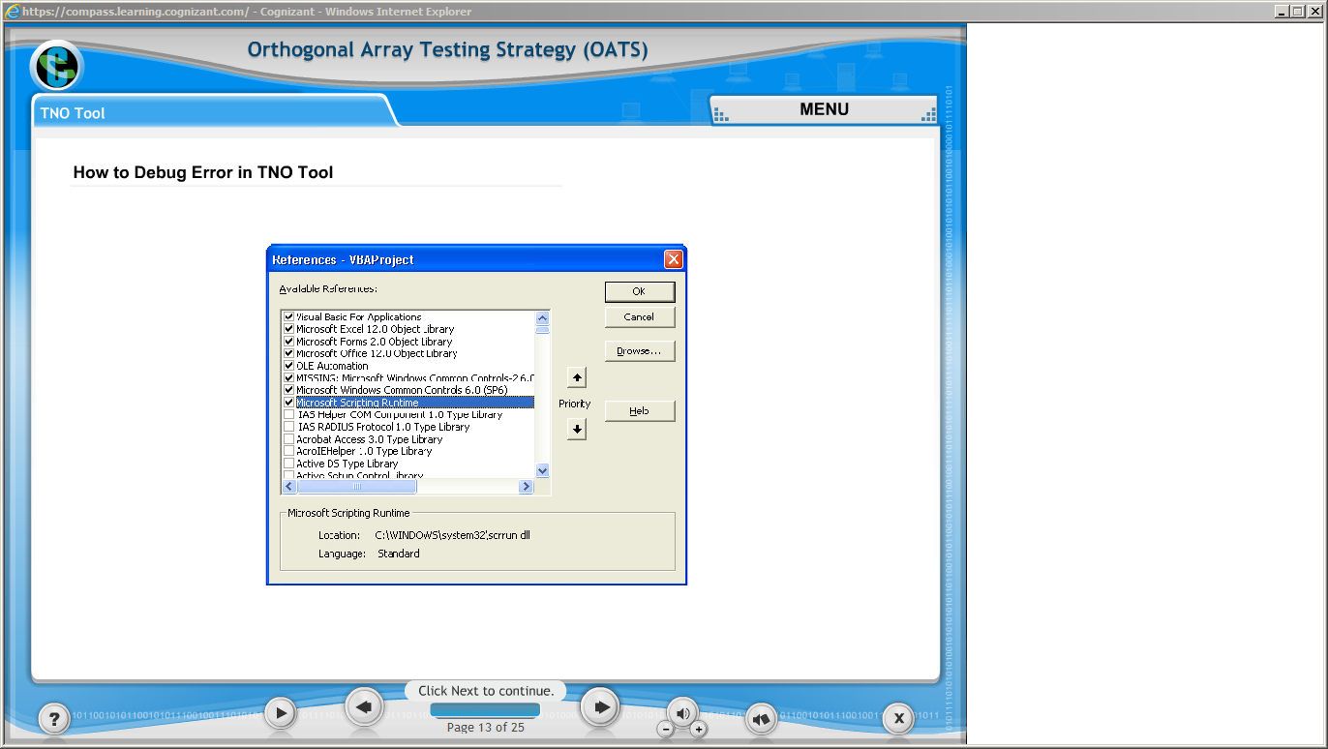](https://compass.learning.cognizant.com/elmprd/elearning/orthogonal_array_testing_strategy/tno_tool/login.htm)

[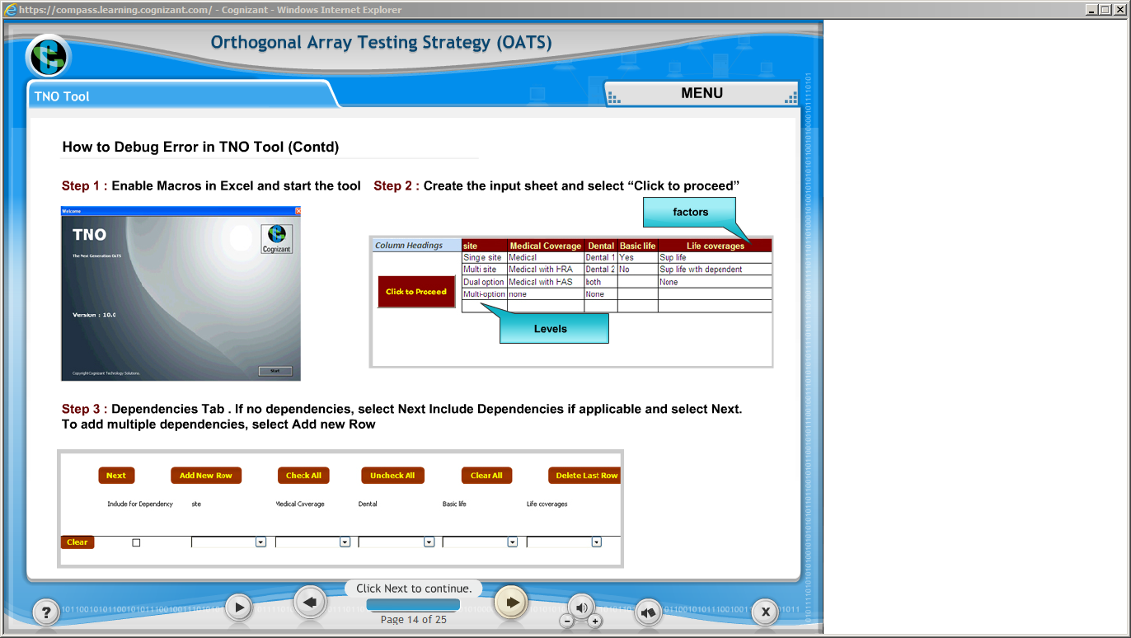](https://compass.learning.cognizant.com/elmprd/elearning/orthogonal_array_testing_strategy/tno_tool/login.htm)

[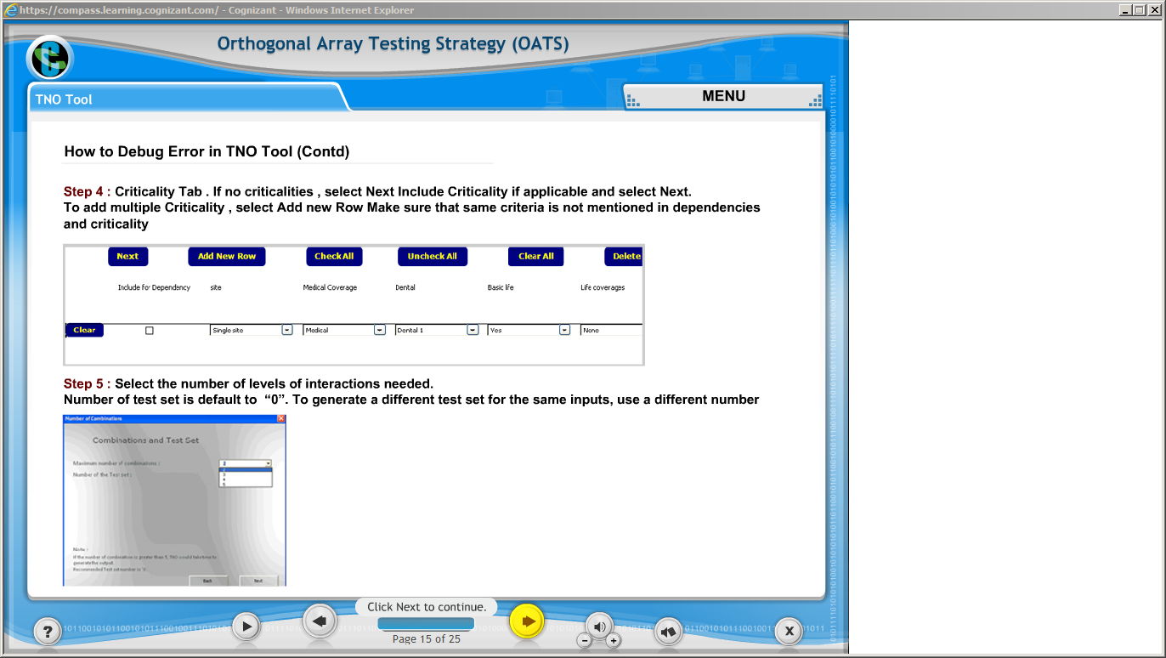](https://compass.learning.cognizant.com/elmprd/elearning/orthogonal_array_testing_strategy/tno_tool/login.htm)

[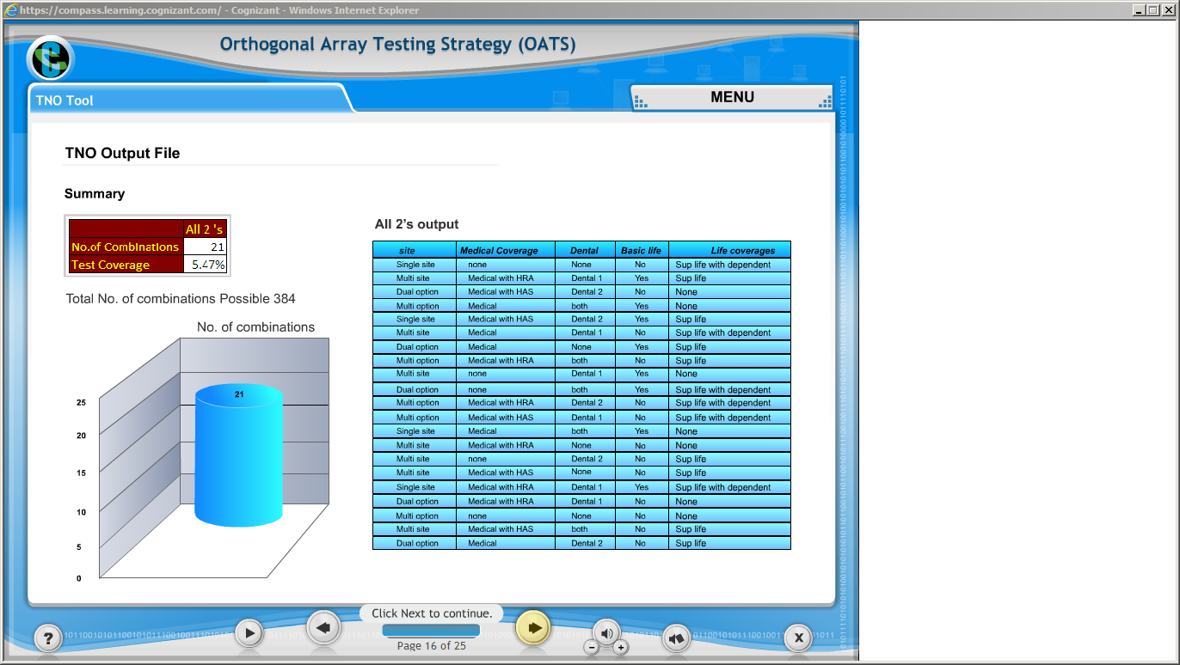](https://compass.learning.cognizant.com/elmprd/elearning/orthogonal_array_testing_strategy/tno_tool/login.htm)

[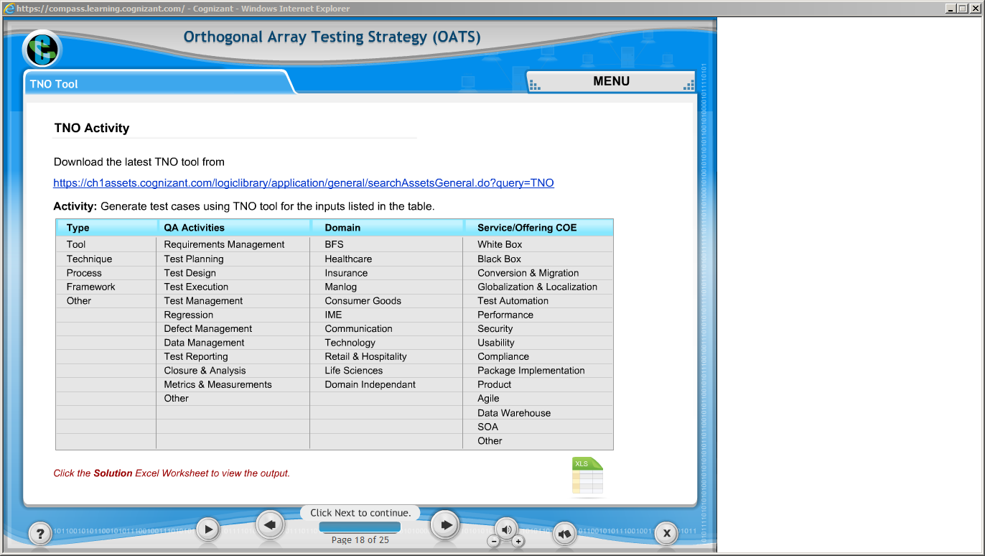](https://compass.learning.cognizant.com/elmprd/elearning/orthogonal_array_testing_strategy/tno_tool/login.htm)

[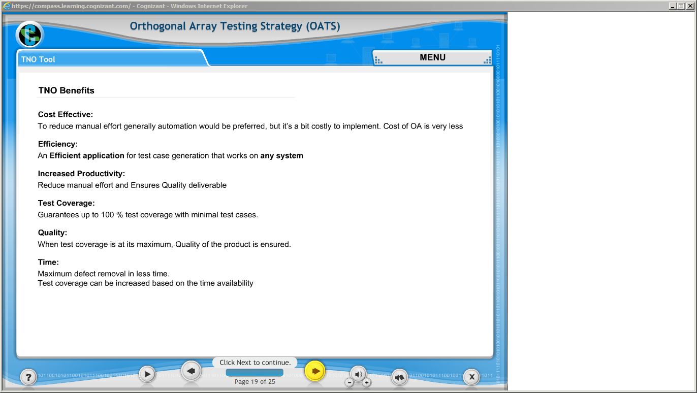](https://compass.learning.cognizant.com/elmprd/elearning/orthogonal_array_testing_strategy/tno_tool/login.htm)

[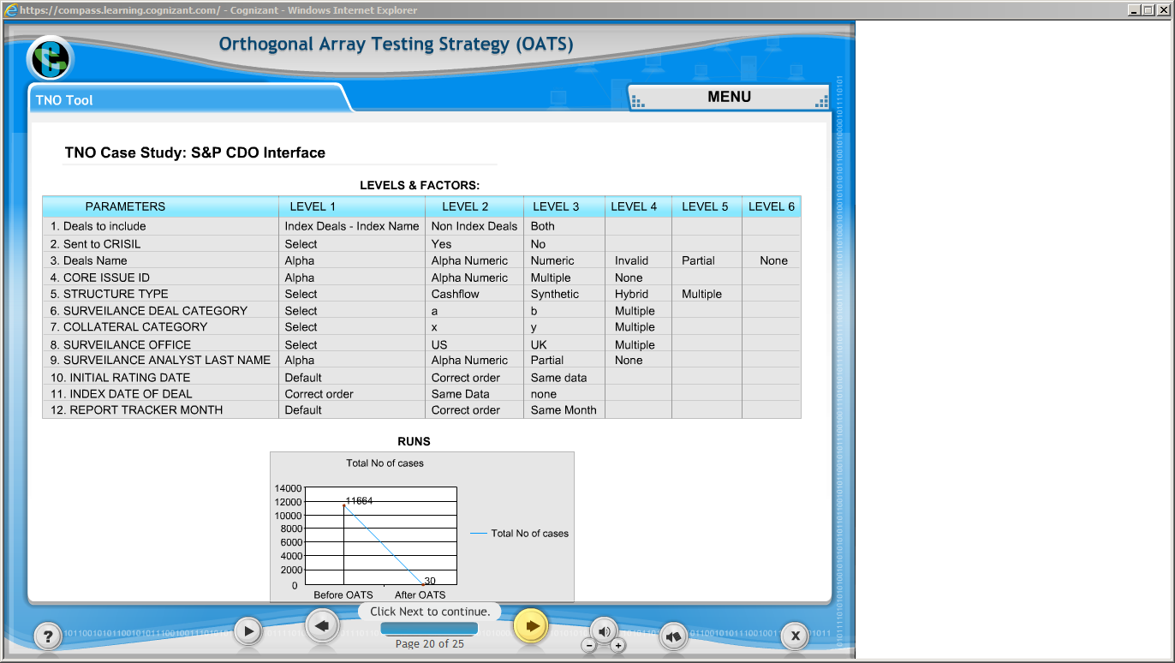](https://compass.learning.cognizant.com/elmprd/elearning/orthogonal_array_testing_strategy/tno_tool/login.htm)

[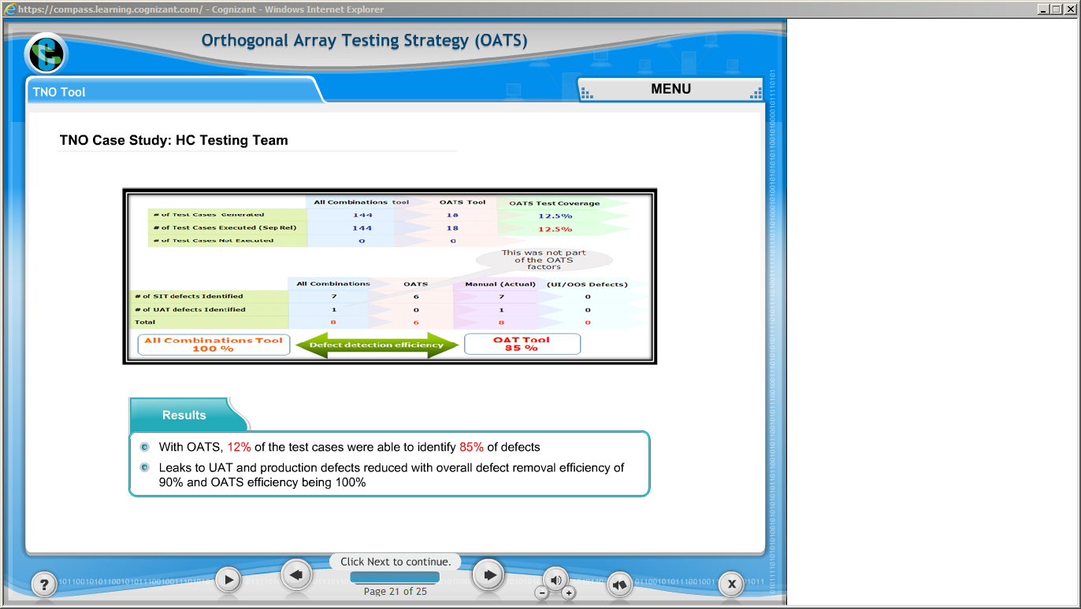](https://compass.learning.cognizant.com/elmprd/elearning/orthogonal_array_testing_strategy/tno_tool/login.htm)

[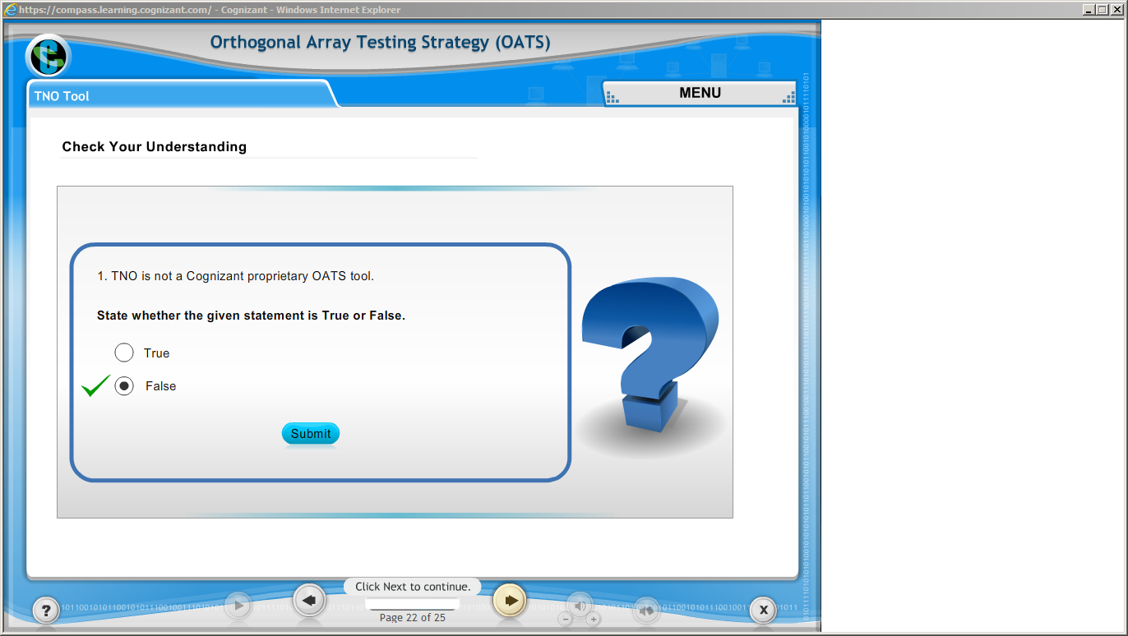](https://compass.learning.cognizant.com/elmprd/elearning/orthogonal_array_testing_strategy/tno_tool/login.htm)

[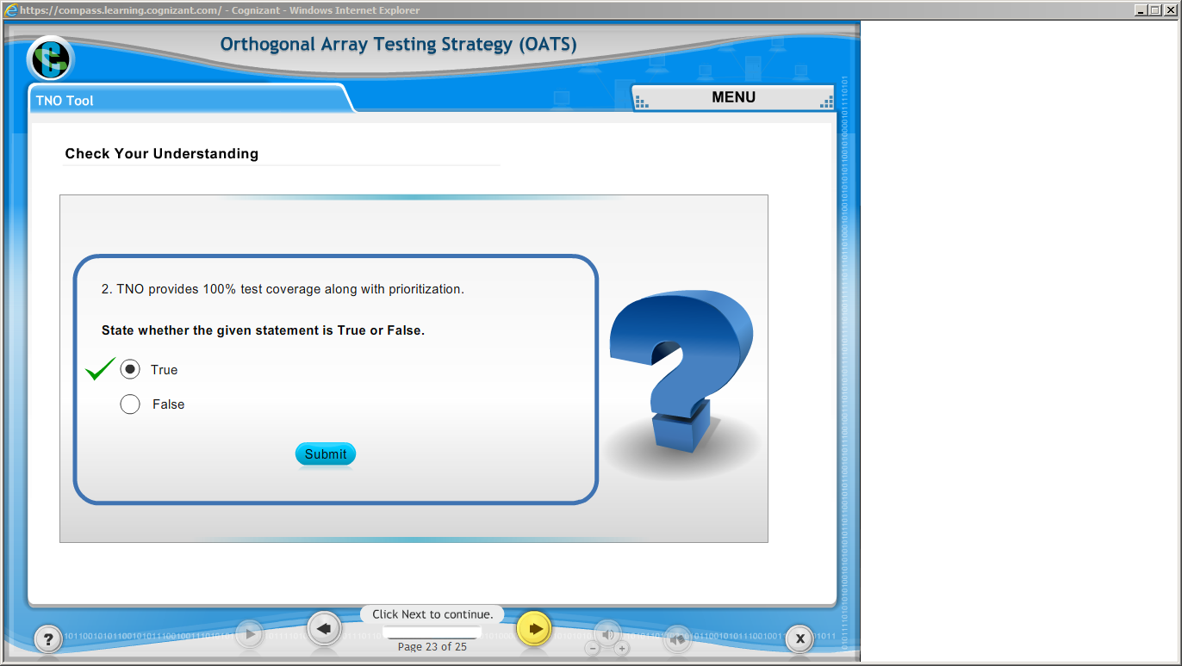](https://compass.learning.cognizant.com/elmprd/elearning/orthogonal_array_testing_strategy/tno_tool/login.htm)

[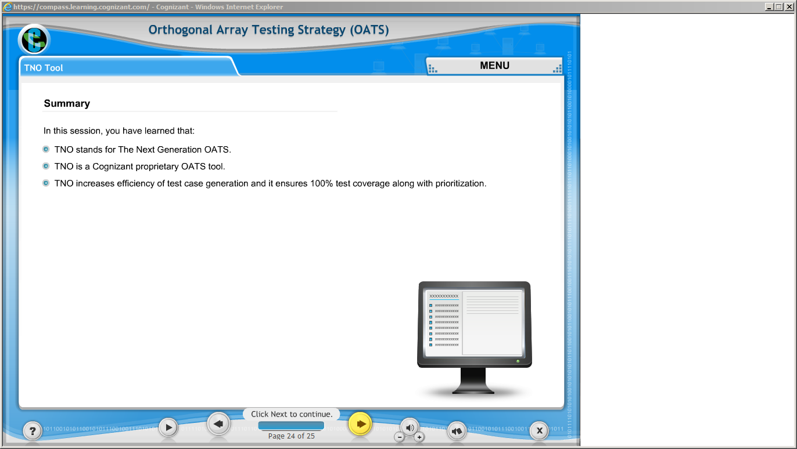](https://compass.learning.cognizant.com/elmprd/elearning/orthogonal_array_testing_strategy/tno_tool/login.htm)

Part 5 d Assessment

Part 6case study